**Making Fabrication Real**

Fabrication for Real Usage, with Real Objects, by Real People

Xiang ‘Anthony’ Chen August 2016

School of Computer Science Carnegie Mellon University Pittsburgh, PA 15213

**Thesis Committee:** Scott Hudson, Co-Chair Stelian Coros, Co-Chair Jodi Forlizzi

Tovi Grossman

*Submitted in partial fulfillment of the requirements for the degree of Doctor of Philosophy.*

Copyright *Q*c

2016 Xiang ‘Anthony’ Chen

**Keywords:** Fabrication, 3D printing, real world, design tools

**Abstract**

The increasingly personal and ubiquitous capabilities of computing—everything from smartphones to virtual reality—are enabling us to build a brave new world in the digital realm. Despite these advances in the virtual world, our ability as end-users to transform the physical world still remains limited.

The emergence of low-cost fabrication technology (most notably 3D printing) has brought us a dawn of making, promising to empower everyday users with the ability to fabricate physical objects of their own design. However, the technology itself is oblivious of the physical world—things are, in most cases, assumed to be printed from scratch in isolation from the real world objects they will be attached to and work with.

To bridge this ‘gulf of fabrication’, my thesis research focuses on developing fabrication techniques with tool integration to enable users to expressively create designs that can be attached to and function with existing real world objects. Specif- ically, my work explores techniques that leverage the 3D printing process to create attachments directly over, onto and around existing objects; a design tool further enables people to specify and generate adaptations that can be attached to and me- chanically transform existing objects in user-customized ways; a mixed-initiative approach allows people to create functionally valid objects from their own design, which addresses real world relationships with other objects; finally, by situating the fabrication environment in the real world, a suite of virtual tools allow users to de- sign, make, assemble, install and test physical objects *in situ* directly within the context of their usage.

Overall my thesis aspires to *make fabrication real*—enabling things to be made by real people, to address real usage and to function with real objects in the world.

**Acknowledgments**

**Contents**

1. Introduction and Overview 1
   1. The Disparity of Creativity 1
   2. The Dawn of Making 1
   3. The Oblivion of the Real World 2
   4. Research Goals 3
   5. Timeline 4
2. Background and Literature 5
   1. 3D Printing: History, Principles and Recent Development 5
   2. Current Research Trends in 3D Printing 7
      1. Optimizing the 3D Printing Process 7
      2. Making 3D Printed Objects with Interactive Properties 9
      3. Innovating Tools and Devices for Fabrication 11
   3. 3D Printing for Real Usage, with Real Objects, by Real People 11
      1. Combining 3D Printing and Real World Objects 12
      2. Involving People into the Fabrication Process 13
      3. Specifying Real World Usage and Functional Requirement 14
   4. Summary of Literature Review 14
3. Techniques for Making Attachments to Real World Objects 17
   1. Existing Attachment Solutions 19
   2. Techniques For 3D Printed Attachment 19
      1. Technique #1: Print-Over 20
      2. Technique #2: Print-to-Affix 21
      3. Technique #3: Print-through 21
   3. Geometric Analysis: Viability 22
      1. Understanding Viability: Collision Detection 22
      2. Attaining Viability: Resolving Collision 24
   4. Geometric Analysis: Durability 25
   5. Geometric Analysis: Usability & Semantics 26
   6. A Pipeline For Printed Attachments 27
      1. Interactive Exploration 27
      2. Model Generation, Printing and Post-processing 28
      3. Software and Hardware Implementation 30
   7. Evaluation 30
      1. Evaluating Time and Material Cost 31
      2. Evaluating Strength of Printed Attachments 32
   8. Summary of Attachment Techniques 35
4. Adapting Real World Objects for Custom Users and Use Cases 37
   1. Scenario Walkthrough: Adapting a Cutter 39
      1. Iteration I: Generating Wrappers for a Better Grip 39
      2. Iteration II: Making Levers to Assist with Clutching 40
      3. Iteration III: Anchoring the Cutter for Situated Use 40
   2. A Design Space of Adaptation Strategies 40
   3. Reprise: Computational Design of Adaptations 43
      1. Techniques for Specifying Types of Action with an Object 43
      2. Computationally Generating Adaptations 44
      3. Adjusting Design Parameters for Customization 45
      4. Attaching Adaptations onto Real World Objects 46
      5. Implementation, Measurement and Fabrication 48
   4. Results and Validation Through Replication 50
   5. Discussion and Summary of Designing Adaptations 52
5. Mixed-Initiative Design for Real World Functional Requirements 57
   1. Sketching an Initial Design 59
   2. Specifying Functional Requirements 60
   3. Iterating a Design with System Feedback and Suggestion 60
      1. Analysis and Feedback 61
      2. Optimization and Suggestion 62
      3. Iterating with User Editing 63
   4. Making a Design Fabricatable 63
   5. Summary of Mixed-Initiative, Functionally-Aware Design 64
6. Supporting Hands-on Design and Fabrication in Real World Context 65
7. Discussion and Conclusion 67
   1. Design for Real Use, with Real Objects, by Real People 67
   2. Obstacles and Solutions of Digitalizing the Real World 68
   3. Design Tools + Fabrication Tech = Physical Creativity 69
   4. Next Generation of 3D Design Tool? 69
   5. Conclusion 70

Bibliography 71

**List of Figures**

* 1. Examples of how existing objects can be augmented using our techniques: a) turning a battery into a LED torch; b) making a magnet from a Teddy bear; c) adding a stand to a glue gun and d) attaching a name tag to a pair of scissors. . . 18
  2. A computational pipeline for designing and fabricating attachments to augment everyday objects. 18
  3. a) The magnet holder printed directly on a teddy bear that was scaffolded on support structures; b) a handle added to an espresso cup; c) strapping to make a reusable 4 pack handle; and d) a bracelet printed through a heartshaped charm. . 20
  4. Example of a print-through process: the printer pauses at a point where the scis- sors can be dropped to interlock with the name tag, after which the print job

resumes. 22

* 1. Print-through provides visual feedback (highlighting intersecting faces) to in- form users of object-object collision that might not look obvious from certain

viewing angle. 23

* 1. Interlocking objects are not always viable for printing: a) the torus cannot be inserted while the structure is being printed due to collision; b) a different orien-

tation makes the print viable. (arrows indicate printing directions). 24

* 1. A heat map is an effective way to visualize the analysis results for adding a han- dle to a wrench: a) red areas indicate a handle cannot be printed over (viability);
     1. emphasizing durability shows preference for areas with small curvature; and
     2. emphasizing balance (usability) shows preference for areas near the center of mass (This assumes the forces applied have the same direction as the surface

normals). 28

* 1. Directly drawing on the object is a simple way to specify the attachment area, such as drawing a stroke around a bottle (a, b) to indicate where to attachment a

strap. (c) a heat map visualization around the selected cross section. 29

* 1. In the Teddy bear magnet example, a) a model is generated with a magnet holder, a connector, and the support structure; b) Tool path view in Repetier-Host: the

extruder pauses and moves away for inserting the teddy bear (c). 29

* 1. To test print-over in comparison to printing in one piece, we used both tech- niques to print attachments on surfaces with varied curvatures and then exerting tangential pulling force. 33
  2. Testing the strength of a 3D printed handle attachment (b) by clamping it on a

table (c) and pulling using a scale to measure force (a). 33

* 1. Strength test results show print-over is strong enough to sustain stress as if they had been printed in one piece. Both our techniques suffer from an increase of sur- face curvature (a) and roughness (b); (c) shows that affixing with straps (150mm

zip tie) is able to sustain over 2.5 kg of pulling, and reacts differently to curvature. 34

* 1. To test strapping in print-to-affix, we increased the curvature between the attach-

ment and the attaching surface and exerted tangential pulling force. 35

* 1. Our main contribution is the tool integration and a formalized design workflow for making 3D printable adaptations onto everyday objects. For example, an occupational therapist can use our tool to explore different strategies of adapting a wire cutter (a), such as creating a wrapper to soften the grip (b-e), adding two levers to assist with clutching (f-h), or replacing one lever with an anchor to

situate the cutter on the work surface (i-m). 38

* 1. Existing examples of adapting everyday objects: a faucet extension (a), a guide

for sharpening drill bit (b), and turning a spray-can to a spray-gun (c). 39

* 1. A design space of adaptations summarized from over 3000 existing examples: five major adaptation strategies support various types of actions, from static grasp and hold, to linear and rotational motion that involves one or multiple parts of

the objects. 41

* 1. The design workflow of Reprise. Start with specifying the types of *action* applied on an object, which serves as input for generating user-selected *adaptations*. The initial design can be further customized by *adjusting* a set of parameters. Finally,

extra fasteners can be added to make adaptations more *attachable* onto the object. 42

* 1. Reprise shows a virtual hand to let the user specify how an object is grasped, such as forming a cylindrical grasp on a knife (a), or a spherical grasp on a bottle

(b). 43

* 1. Reprise uses a spherical control for specifying pushing/pulling an object, such as pressing a button on a remote control (a), or pulling a zipper (b) 44
  2. To specify rotating an object, Reprise lets a user select where the object is held (a), on which plane it is rotated (b), and the fulcrum of rotation (c). The red

arrow shows the rotation arm along which a lever can be generated (d). 44

* 1. To specify clutching, the user selects the two parts of the object that are being clutched and then the fulcrum. The red arrows indicate the directions of the clutching arms (a). The user can generate a lever for clutching the spray bottle,

while holding its body in hand (b). 45

* 1. Reprise lets the user specify moving one object towards or away from another,

such as putting a key into a lock hole. 45

* 1. Reprise can generate a wrapper–a cylindrical structure bounding part of an object

(a), or an extension–an extrusion from a selected area of the object (b). 46

* 1. Besides using sliders, users can also click a button to generate a large set of design variations (ab), from which they can select one that best matches the design they have in mind, and continue to develop it from that model (c). 47
  2. Reprise provides a simple technique to split an adaptation in halves so an object,

such as this fork, can be put inside a wrapper (Figure 4.17a). 47

xii

* 1. A pipe clamp, provided by Reprise, attaches the generated stand (a) to the object.

Clicking on the object places the pipe (b). Another stroke cuts it open and adds

a pair of clamps (cd). 48

* 1. Beams can further support the object for an adaptation. To generate one, simply

select a point on the object and another point on the adaptation. 48

* 1. As the phone’s screen is marked as inaccessible (red) by an adaptation, the gen- erated handle avoids covering that area. 49
  2. Reprise also provides an SVG file for making a measuring tool for adaptations

that require fitting users’ hand or fingers. This one shown above was laser cut. . . 49

* 1. Replicated wrapper/extension examples. Ninjaflex was used for the fork wrapper (a), zipper handle extension (b), and the bottle lid wrapper (c). Nylon-based soft

material was used for the cutter 51

* 1. Replicated handle examples. 51
  2. Replicated lever examples. 52
  3. Replicated anchor/stand examples. 53
  4. Replicated guide examples. 53
  5. Combining multiple adaptations: a handle (a), a guide (b) and an anchor (c) can

be combined into one (super) adaptation (d). 54

**List of Tables**

* 1. Prediction models for printing time of attachment techniques and data from a exemplar object+attachment. 31
  2. Prediction models for material cost of attachment techniques and data from a exemplar object+attachment. 31

**Chapter 1**

**Introduction and Overview**

## The Disparity of Creativity

As computers and the Internet become increasingly ubiquitous, people are now able to create or curate a variety of digital content. Today it only takes a few minutes to build and customize a personal website. Anyone can write a beautifully typeset blog without knowing anything about layout, font, or kerning. Writing and publishing apps has never been easier. You can even build your own virtual reality without making a step out of your dorm room 1, or catch an army of Pokemons as you go 2. The digital realm is such a wonderland where anyone, with a mouse, a keyboard or even just a touch screen, can become the greatest architect of their own virtual world.

In contrast to the prosperity of the cyberspace, people’s ability to transform the real physical world has always been quite limited. In fact, since the second industrial revolution, people have been increasingly reliant on manufacturing and retail to procure what they want–the making and craftsmanship of individuals gradually became obselete and increasingly irrelevant. More recently, the convenience of online shopping and low-cost, fast shipping further disincentizes people from make things on their own.

Thus we are faced with a disparity of creativity: we are so freely and capable of building almost anything in the digital realm; we are so limited and much less capable of making things in the physical world.

## The Dawn of Making

Fortunately, the advent of low-cost fabrication technology (most notably 3D printing) has given rise to a dawn of making. With 3D printing—a simple layer-by-layer additive manufacturing approach—people can simply import a 3D model, let the printer take care of the fabrication pro- cess and produce a physical artifact of their own design. Even without professional 3D design skills, people can go to online communities such as Thingiverse3 to find and share 3D mod-

1Minecraft. <https://minecraft.net/>

2Pokemon Go. <http://www.pokemon.com/us/pokemon-video-games/pokemon-go/>

3Thingiverse. <http://www.thingiverse.com/>

els with one another. These communities have curated a large set of things a person would want to make—from reconstructed model of Roman sculpture, to a fully functional plastic bottle shredder. Meanwhile, the availability of various materials further broadens the scope of making. People can now print things that are soft 4, sculptable 5, chemical-resistant 6, structurally strong 7, magnetic 8, metalic 9, edible 10, or self-actuating [34].

3D printing11 has served as a platform that aggregates research and development from various domains to collectively enable people to transform their imagination and creativity into real objects that could impact their real lives. Indeed, such real world impact, whether it is small life hacking or a world-wide collaborative project [59], is what makes 3D printing stand out from other consumer software and electronics.

## The Oblivion of the Real World

Given such fabrication capability, one natural approach to impact the real world is to use the printers to constantly produce new things–bespoke objects or people’s own creative designs. While this has been an important aspect of 3D printing, the sole focus of making new things is oblivious of a whole world of existing objects that we are already interacting with at a daily basis. Rather than always producing things from scratch, perhaps another important mission of 3D printing is to closely couple with and build upon real world objects. In this way I believe we can maximize our ‘degree of freedom’ in making things: people can choose to fabricate something entirely new, or to base their design on–and times in combination with– existing things.

Besides existing objects, another important aspect that is often ignored in fabrication is peo- ple. It is true that 3D printing is bringing people back to making things. The kind of making it affords, however, is quite different from traditional practices. Traditional fabrication–everything from jewelry making to wood working–is extremely hands-on. Even later using modern tools and machinery, this making process still requires makers to closely interact with, control or ma- nipulate physical material or artifacts. In contrast, 3D printing, especially the actual printing process, involves very little of such hands-on exercise. Minimally, a person only needs to press a few buttons to fabricate an object: download a 3D model, convert it to machine-readable code, and send it to the printer. In such a way of making, the real maker is not the people but the machine: there is currently no way people can contribute to the printing process once the ‘Print’ button is pressed.

4NinjaFlex. <https://ninjatek.com/>

5Sculptable material by Adam Beane Industries. <http://www.adambeaneindustries.com/>

6FilaOne GRAY by Avante Technology. <http://www.avante-technology.com/>

7PC-Max by Polymaker. <http://www.polymaker.com/shop/polymaker-pc-max/>

8Polymagnets. <http://www.polymagnet.com/polymagnets/>

9Yibo3D. <http://www.yibo3d.com/>

10Edible six-pack holder by We Believers <http://www.webelievers.com/>

11As I focus on 3D printing as the main fabrication technique, hereon in this thesis I used the terms ‘3D printing’ and ‘fabrication’ interchangeably

## Research Goals

The goal of my thesis research, in brief, is to *Make Fabrication Real*– *(i)* my primary goal is to enable a making process (executed by 3D printers) that is closely integrated with real world objects and usages and; *(ii)* my secondary goal is to explore ways whereby the making process can benefit from real people’s involvement.

To achieve the first goal, I build design tools that provide support for people to harness 3D printing not just to make things from scratch, but to extend, adapt or combine them with existing objects for individualized needs or custom use cases. To achieve the second goal, I explore fabrication techniques that invite and enable people to ‘get their hands dirty’ and more actively participate in the making process; meanwhile, 3D printing ‘fades’ into the background, acting as a supporting role to facilitate this process.

These research goals are manifested in four projects, as described in the remainder of this thesis.

* + - **Chapter 2** sets the scene with a brief review on the background of 3D printing–its core technical components and principles, as well as some recent developments in both research and development.
    - **Chapter 3** addresses the attachment problem, which is a fundamental requirement for using 3D printing to augment real world objects. Specifically, I present Encore—a design tool with a suite of techniques that allow a user, with a unmodified consumer grade 3D printer, to directly print attachments over, around or through existing objects.
    - **Chapter 4** builds on the attachment techniques, and focuses on enabling the design tasks of making such attachments that work with existing objects. Specifically, I describe Reprise— a design tool that provides simple interaction techniques and computational geometry for specifying, generating, customizing and fitting adaptations onto existing objects.
    - **Chapter 5**: Both Encore and Reprise focus on extending or adapting real world objects, which allows people to transform objects in their everyday lives. However, such transfor- mation only adds small ‘delta’ as it never goes beyond what existing objects were originally designed for.

As a next step, I propose Mashup—a design tool that takes a mixed-initiative approach to guide users to compose and fabricate self-contained objects based on the functional re- quirements they will face once installed and deployed in the real world. Specifically, users start with sketching a design from their intuition; the system in the background optimizes their initial design based on the functional requirements; then users can further tweak the design while the system provides on-demand feedback and suggestion for keeping it func- tional.

* + - **Chapter 6**: Now that the range of making has broadened from incremental augmenta- tion to standalone functional objects, a one-shot 3D printing job might no longer be the preferred making solution.

My next proposed tool will seek to support people’s hand making, assembling, installing and testing of functional objects in the real world. Specifically, I will develop Divje–a virtual tool using augmented reality to guide, assist or provide custom support for people

during their manual fabrication process. Divje provides a unified making platform that integrates 3D design and modeling into hand making with material and artifacts. With Divje, people are immersed into both the digital and the real world of making: they can use virtual tools to sketch a design, which guides them to use physical material to make the corresponding prototype; as they build up the physical work they can also in parallel refine the model digitally. Instead of switching back and forth between the digital and the physical, Divje blends them together and presents the best of both worlds to enable people to bring their design to life with their hands.

* + - **Chapter 7** concludes this thesis by reflecting on my exploration of these projects, dis- cussing issues and questions that arise, and suggesting new opportunities for future work.

## Timeline

As shown in the outline of my thesis, so far I have finished Project Encore (Chapter 3) and Reprise (Chapter 4). I am currently working on Mashup (Chapter 5) and also preparing for a fourth project. Below is my timeline for finishing up all the projects.

Summer 2016 *•* Developing mixed-initiative tool (Mashup) for functional design

* + - Learning and setting up Augmented Reality (AR) devices

*•*

Fall 2016 *•* Writing up Mashup for CHI 2017 submission

* + - Literature survey on AR-assisted manufacturing
    - Designing AR-based design and fabrication environment

*•*

Winter 2016 *•* Prototyping interaction techniques

* + - Integration into a system
    - Deploying the system for actual fabrication

*•*

Spring 2017 *•* Writing up for UIST 2017 submission

* + - Writing up the corresponding thesis chapter

*•*

Summer 2017 *•* Thesis writing

* + - Thesis defense

**Chapter 2**

**Background and Literature**

To set the scene, I first present a brief review of 3D printing’s history, its working principles and some recent development of the technology. Next I shift the focus to academic research, where several trends of research have been capitalizing on the democratization of 3D printing, tackling problems related to optimizing the 3D printing process, making 3D printed objects more interactive, and innovating new types of fabrication tools or devices. As fabrication is a relatively new topic in Human-Computer Interaction (HCI), my hope is to draw together all this recent work to build up the backdrop of my thesis research. Last but not least, I focus on reviewing several papers that are specifically related to my research goals, which also prelude the following chapters where I describe my main results. 1.

## 3D Printing: History, Principles and Recent Development

The first 3D printing concept was published in 1981 by Hideo Kodama2 from Nagoya Municipal Industrial Research Institute in Japan. He proposed a type of photopolymer rapid prototyping system that could build up layer after layer, each of which represented a slice of a 3D model. However, Kodama’s idea did not seem to take off, as the first commercially available 3D printer only debuted 10 years later, which was a Fused Deposition Modeling (FDM) machine produced by Stratasys.

**XAC: non-minor revision here** Today, the term ‘3D printing’ loosely refers to a class of such additive manufacturing techniques [21]. FDM is a primary family amongst these tech- niques. Comparatively, FDM printer has fairly simple working principles and is relatively inex- pensive to build. These machines would fabricate an object following a bottom-up, layer by layer approach. Specifically, in an FDM printer, material (often called ‘filament’) is melted and ex- truded through a hot end—this part of the printer is called an extruder. Each extrusion produces a thin line of material, which is then laid down on a print bed or some printed parts of an object. Several motors drive the extruder and the print bed to move relatively to one another, allowing material to be laid down in pre-computed locations, forming geometric patterns. Specifically,

1There is some other closely related work that will be reviewed inline with specific projects, as I feel the discus- sion of them is more appropriate within those contexts rather than in a standalone chapter.

2<http://www.avplastics.co.uk/3d-printing-history>

each time the printer will create a 2D layer, which represents a cross section of an object; then it moves vertically up to create the layer above the previous one. This process is repeated until a fully 3D object is created from a stack of the 2D layers.

As simple as this process seems to be, it comes with certain limitation, such as larger layers might be not be supported by smaller layers beneath them, causing the object to ‘collapse’. In the next section, I will review existing solutions and research that address this problem.

Besides FDM, there is a wide range of other additive manufacturing techniques; here I review several representative examples that have been widely adopted and used. Note that the general principle—layer-wise manufacturing of objects—is somewhat similar to FDM; what differs is often the types of material as well as the way the material is consolidated into an object’s layers.

* + - Photopolymerization approach, such as stereolithography [83], uses UV-curable photopoly- mer resin as material. UV light cures a layer to create the cross-section of the object, and then the platform is lowered and the next layer is laid down; this process is repeated until all layers of an object is produced.
    - Sintering-based techniques, such as selective laser sintering [84], first lays down a layer of powder (e.g., metal) and then uses laser to sinter part of the powder layer based on the geometry of the cross-section . Similarly, next the platform is lowered and the next powder layer is laid down and sintered to continually build up an object.
    - PolyJet3—a patented technology by Stratasys—is similar to inkjet printing except that liquid polymer is jetted, which is then cured, usually using UV light.

3D printers’ additive approach simplifies the making of objects with arbitrary shape by almost brute-forcedly treating them unexceptionally as a stack of layers. However, even with such simplified working principles, the making of 3D printers was never a trivial task. Primarily, there have been two challenges: *(i)* precision—the thinner each layer could be the higher resolution the final object; *(ii)* material—the more material can be fed into a printer the more variety of objects users can make. The pursuit of high precision and special material has always been pushing the development of 3D printers.

Perhaps due to such a high technical bar (in both manufacturing and usage), 3D printers in their earlier years were never considered or envisioned as a piece of consumer-grade equipment. The expensiveness was another important factor. Indeed, according to 3D Printing Industry, not until 2007 did the market see the first 3D printer under $10,0004. Even this price point was still way too expensive for consumer use. (In comparison, the first iPhone, which also debuted in 2007, was under $600.)

**XAC: non-minor revision here** Thus the dawn of making never took place in traditional 3D printing industry; in fact, many have attributed the democratization of 3D printing to some early do-it-yourself (DIY) projects that made the first steps of making affordable, (relatively) easy-to- build fabrication machines. For example, Fab@Home from Connell University is a kit available for general public to produce and assemble a multi-material 3D printer [81]. The RepRap project5 was engendered by Adrian Bowyer from the University of Bath in early 2004. The RepRap

3<http://www.stratasys.com/3d-printers/technologies/polyjet-technology>

4[http://3dprintingindustry.com/3d-printing-basics-free-beginners-guide/](http://3dprintingindustry.com/3d-printing-basics-free-beginners-guide/history/)

[history/](http://3dprintingindustry.com/3d-printing-basics-free-beginners-guide/history/)

5<http://reprap.org/>

July 30, 2016 DRAFT

printer, foremost, is a fully functional FDM printer; further, the name stands for **Rep**licating **Rap**id-prototyper, meaning that this printer can be used to replicate new ones of its kind by producing constituent parts for assembly. This was a significant mission of this project, as it would provide a solution for making 3D printers widespreading to a large group of people.

Later in around 2009, Makerbot became one of the earliest consumer 3D printer manufactur- ers. In just a few years’ time, numerous small or large companies emerged and joined the wave of making 3D printing affordable and usable to non-professional, non-expert users. To date, the cost of a consumer 3D printer has dropped to less than $300. These low-cost 3D printers can be found in people’s garages and basements, in educational and research institutes, and in hardware and facility stores. In 2013, Gartner projected a growth of 95.4% in consumer and enterprise 3D printer shipments worldwide through 20176.

In academic research community, the availability of 3D printers not only makes it possible to bring 3D designs to reality, but also continuously inspires new ideas and problems, which I review in the following section.

## Current Research Trends in 3D Printing

As mentioned above, 3D printing is a very specific type of fabrication technique with relatively simplified principles following a bottom-up, layer by layer approach. It currently stands at the intersection of several research areas, including mechanical engineering, material science, com- putational geometry, computer graphics, and HCI. My thesis research is primarily situated in the area of HCI, and partially related to computational geometry and computer graphics. The liter- ature review in this section spans these three areas (primarily in HCI) with an attempt to weave prior work into a backdrop of my own research.

Within this scope, research on 3D printing by and large converges to the following three trends: *(i)* optimizing the 3D printing process, *(ii)* making 3D printed objects with custom prop- erties, and *(iii)* innovating tools and devices for fabrication. While such categorization is by no means complete (nor are the trends mutually exclusive to one another), it serves well to organize a massively growing body of work that involves 3D printing.

### Optimizing the 3D Printing Process

Although 3D printing can expressively fabricate objects of almost any shape, the process itself has some inherent limitations.

**Speed** is perhaps the most noticeable problem. **XAC: Removed the estimate. I am afraid giving specific examples would just get bogged down to more and more details: how complicated is the geometry, what printer is used, what’s the setting, what’s the filament, etc.** One direct consequence of low speed (or longer print time) is a slower cycle of design iteration: users have to wait a long period of time before being able to tangibly tell whether and how well the design works. This is against the general iterative design approach, in which it is imperative for people to quickly prototype, evaluate and continually develop their design.

6<http://www.gartner.com/newsroom/id/3139118>

July 30, 2016 DRAFT

3D printing has become a bottleneck that interrupts the flow of people’s creation, reflection and improvement process.

To solve the speed problem, researchers have taken an approximation based approach–instead of following the default slow printing process, they try to modify and accelerate it at the cost of lowering the fidelity of the printed result.

For example, faBrickation uses Lego bricks to replace parts and components that would oth- erwise need to be 3D printed [39]. In this way, assembling existing Lego bricks makes it faster to approximate the target object than printing it from scratch. The accompanying design tool converts an existing 3D model into a ‘low-fi’ version consisting of Lego bricks and outputs in- structions for assembly. As this approach sacrifices the fine resolution of the original model, it also allows users to specify parts or components that need to be precisely 3D printed: a com- bination of both yield a flexible way to accelerate the making of an object. Similarly, Platener introduces laser cutting—a much faster fabrication process—into 3D printing. The design tool looks for parts of an object that resemble planar structures, and uses laser cut ‘plates’ to replace them, thus reducing the extra time if otherwise using 3D printing [6].

Besides approximation, it is also possible to print objects incrementally. For objects with large volume, researchers have come up with techniques that build these objects around a (large) existing component. For example, RevoMaker is a modified 3D printer wherein an existing block of material can be clamped on, rotated, and new parts can be printed on each side of it to finish a complete object [20]. CofiFab presents a coarse to fine approach, which first produces a coarse approximation of an object as the base (often using faster methods such as laser cutting), and subsequently fabricates parts with finer-grained details onto it [63].

A third approach of acceleration is to redesign the printing process. WirePrint, for example, converts a 3D model into a ‘low-fi’ custom wire mesh structure amenable to be printed fast [38], especially when using printers with high Z-axis speed (e.g., the Delta printer7). Similar to how ‘low-poly’ tessellation saves space for storing 3D models, ‘low-fi’ printing saves time for making 3D objects. This approach was further developed in On-the-Fly Printing–a custom 3D printer that uses cooling to further accelerate the WirePrint approach and adds a rotation mechanism so that new ‘wires’ can be added or removed at arbitrary points [43]. This enables incremental on-the- fly printing that happens as users are virtually building or editing a 3D model, thus accelerating the process with parallelization.

The requirement of **support structure** is another concerning problem of 3D printing. De- spite the universal simplicity of FDM, its layer-by-layer approach has a inherent limitation: each layer needs to ‘stand’ on the previous ones. One can imagine that if a layer is much larger than the ones below it, part of this layer will have to stand on thin air, which is called an ‘over- hang’ situation. To solve this problem, a general approach is to provide some sort of ‘support structure’—sacrificial structures that serve to support overhanging parts, and then removed from the final print. Essentially, support structures are put in place, and fabricated simultaneously with the target object to artificially create no-overhang situations. What is problematic about adding and printing these support structure is that it costs extra time and material to ensure stable support, exacerbating the speed problem. Further, as they become integral parts of the original

7Instead of moving the print head orthogonally, Delta printers apply the delta robot principle, which uses three arms to position the print head in 3D space.

July 30, 2016 DRAFT

object, it is generally difficult to remove them post hoc, unless the printer uses a separate, easily removable material specifically for support structure.

In the research community, there have been several approaches focusing on solving the first problem of support structure. Specifically, the goal is to reduce the cost of extra time and mate- rial without making these structure less stable (i.e., the overhanging layers can still stand through the 3D printing process). Schmidt and Umetani proposed a top-down procedural approach to generate support structures, which results in a significant reduction in wasted time and mate- rial compared to using manufacturer-provided method [57]. The tree structure in Schmidt and Umetani’s work is further improved by Dumas et al., who propose a bridge structure to provide stronger and more stable support [18]. Bridging is a specific FDM technique wherein the printer extrudes material horizontally trying to connect two end points at the same level. Although this is also an overhanging situation, the bridge is usually able to stand because of the tension of the extruded material as well as the support at the two ends (similar to how a hammock can be tied to and hung between two structures and even support human weight). Dumas et al.’s work exploits this bridging capability to hierarchically build up steady scaffolding in a cost-efficient way.

**Structural quality** is not just a issue for support structure, it also affects the usage of the 3D printed objects. Material is perhaps the primary factor for structural quality. Beyond traditional plastic-based filament, innovation in material, such as carbon nanotube8 and polycarbonate-based filament9 has proven to provide, amongst other improvements, stronger structural properties. However, material is not the only variable in deciding a printed object’s strength. The layer by layer approach of FDM printers has caused a side effect of anisotropic strength–meaning the structural property of an object is dependent on the direction in which it is printed. Specifically, a printed object is generally much stronger within layers than between them, as adjacent layers are anisotropically adhered rather than isotropically integrated. This unique characteristic has motivated several interesting projects, such as Umetani and Schmidt’s cross-sectional analysis [73] and Ulu et al.’s build orientation optimization [72], both of which attempt to find an optimal direction to print an object so as to maximize its strength (or minimize the effect of cross-layer anisotrophism).

All this work above focuses on understanding the limitations, optimizing the printing process and has solved a number of interesting problems related to speed, overhang and structural quality. Next I move on from the printing process and look at the design of objects that gives them custom properties once printed.

### Making 3D Printed Objects with Interactive Properties

One compelling power of 3D printing is the customization of objects–the ability to transform them into something with unique properties customized by the users.

One well-explored approach to achieve this is by embedding custom structure or compo- nents into a printed object. This approach can often result in more interactive 3D prints, as the embedding enables the objects to transmit various signals with input and output capabilities. For example, Printed Optics is a general technique that embeds optical elements into objects to

8<http://www.3dxtech.com/>

9<http://www.polymaker.com/shop/polymaker-pc-max/>

serve as display or optoelectronic sensors that react to how people manipulate the objects [7,](#_bookmark154) [85]. InfraStruct expands this idea to the terahertz (or sub-millimeter) spectrum: through terahertz imaging information can be encoded into or read from the internal design of 3D printable objects [86]. Accoustruments further pushes this approach with transmission of a near-ultrasound swept frequency signal through a custom-built embedded tube. Upon reception of the signal, it can characteristically describe users’ interaction with a printed object. In particular, this approach seems more deployable to smart devices, as audio signals can be received by their microphones, and 3D printed enclosures can be easily attached to the devices [31]. Similarly, Lamello 3D prints objects with structures that produce distinct acoustic signals when interacted with [56], such as a slider whose thumb brushes through a comb-like structure and produces distinguishable sound corresponding to its position.

It is also possible to embed and analyze other types of signal. Vazquez et al. manipulate air pressure inside a printed object with custom material and internal structure, which can also afford a similar class of interaction [76]. Similarly, Schmitz et al. embed liquids into 3D Printed objects to sense tilting and motion [58]. Vasilevitsky et al. embed structures within 3D printed mechanical components that enable the sensing of their mechanical states through electronic signal, such as a voltage divider in a gear and a variable capacitor in a hinger [75].

All this work above has pursued a close coupling of an object’s intrinsic geometry and the added structures or components that give rise to new–mostly interactive—properties. In Graph- ics, researchers also have explored other physical properties of printed objects, such as making imbalanced objects stand [47], or making static objects easily spinnable [2], both of which by optimizing their internal material distribution.

Other work also investigates a ‘looser’ way of making 3D printed objects interactive via instrumenting extra components, often as a post processing step. For example, Sauron instru- ments mirrors inside a 3D printed object, such as a game controller, and uses a light source and a camera to detect user interaction via light redirection, such as sensing the button presses on different locations of the controller [54]. Makers’ Marks further facilitates the prototyping pro- cess using sculptable material (e.g., clay) to create physical models with add-on mechanical or electronic components. A vision-based approach then extracts the location information of these add-ons, which subsequently inform their final installation on 3D printed objects [55]. Jones et al. explored a similar approach, but instead building the fiducial marks as part the sculpted model, which then allow the scanning software to identify widget types and locations, and create structure and space for mounting them [28].

**XAC: how to scope this?** Another approach for making objects more interactive is to innovate on the printing material. For example, bioLogic uses Bacillus subtilis—a type of bacterium that exhibits hygromophic behavior in response to changes in humidity. Specifically, it is shown that this type of bacteria can be used to create bio-enabled actuators made of a composite of the cells, such as making the petals of a flowers unfold when watered, or making areas on clothing open when the wearer sweats [89]. A follow-up project of this work further shows how to build an FDM styled printer (with a key component of a progressive cavity pump) that can utilize this type of material for fabrication [77].

### Innovating Tools and Devices for Fabrication

The expressiveness (as well as limitations) of 3D printing has cultivated research on improving its process and diversifying the printed object’s properties and behaviors. Further, it also inspired innovation on new fabrication tools and devices that are based on, or at times go beyond the traditional FDM approach.

One fairly customizable component is the extruder. For example, the ‘Teddy bear printer’ is able to 3D print soft object with needle-felted yarn. While the architecture of the printer is largely based on a conventional FDM machine, the key innovation of a custom print head contributes to a vastly different material usage and property. Specifically, the custom print head is able to handle the extrusion of and the piercing and entangling with soft fibre, while leveraging the along- axis movement to formulate the geometry of print [24]. The aforementioned xPrint project also innovates the extruder of a convenitional FDM printer, allowing it to handle solution material, while also able to be plugged in with other modules, such as ventilation and mechanical stirs [77].

It is also possible to combine both subtractive and additive manufacturing into one single printer. Scotty is a realization of this concept: as an object is milled away, each layer is scanned; the digitalized model can then be encrypted, sent to another printer, and printed using the additive approach [40].

Another direction is to extend the degree of freedom (DOF) of a conventional printer. One example of this approach is Peng et al.’s On-the-Fly printing—by adding two rotational DOF to a printer, it is now possible to print an object incrementally from various points and orientations, rather than always follow a fixed direction [43].

Other researchers also attain to augment the ‘vision’ of a 3D printer. Since there is no feed- back loop in a conventional printer, the machine has no knowledge or awareness of the object that is being printed, thus no ability to prevent errors or improve upon its current state. To overcome this weakness, MixFab provides a mixed reality environment for users to model their design while juxtaposing it with real objects [78]. To truly integrate ‘vision’ into the printing process, MultiFab employs cameras and machine vision techniques to enable the printer to self-calibrate, scan object or partial prints, and perform self-corrections [61].

## 3D Printing for Real Usage, with Real Objects, by Real People

Amongst all this plethora of recent work, there is a strong focus on innovating the printing process, material and machine design, which enables more efficient printing, a larger variety of printable objects, and different fabrication techniques to empower and realize a user’s creativity. While all this advancement supports an end-to-end pipeline of fabricating new things, it limitedly assumes that objects always have to be made from scratch. What about a world of things that already exist? Should they be discarded and replaced, or rather augmented and built upon? What usage and functional requirements should be considered when augmenting or in general dealing with real world objects? How to specify these requirements in the design process? Further, lots of existing work also worships a complete automation of the fabrication process where sometimes

11

the user’s act of making is reduced to a few button presses. Does this limit people’s innate creativity by keeping them ‘out of the loop’? In this section I review several key existing projects that investigate these questions - specifically, how should 3D printing involve real objects and real people.

### Combining 3D Printing and Real World Objects

By and large, existing work has explored two ways of combining 3D printing and real world objects: *(i)* making objects that are composed of both 3D printed parts and existing things as components, and *(ii)* using 3D printing to augment real world objects.

**Composing target objects with real world objects.** Research that follows the first approach is perhaps motivated by the need to overcome the limited speed of 3D printing. If it is possible to substitute 3D printed parts with something that already exists, less of the object needs to be printed hence smaller amount of overall time.

The aforementioned faBrickation project takes a quite radical approach substituting the ma- jority of an object with lego bricks while only keeping precision-senstive components to be 3D printed [39]. For example, to make a headmounted phone case (for virtual reality applications), everything except the lens holder can be assembled using lego bricks. The design tool performs the conversion from the original geometry to lego-based composition and outputs instructions for assembly. It is obvious that lego bricks only provide fairly limited resolution; however, it man- ages to instantiate a rough object of a user’s design, which is amenable to the iterative design process. Another project by Luo et al. goes beyond prototyping and attains to make functional object with lego bricks. In particular, they apply a force-based analysis to achieve a layout of lego bricks that makes the target object stable even at a fairly large scale [33].

Laser cut pieces can also be used to substitute 3D printed parts, which is demonstrated in the aforementioned Platner project [6]. It is worth noticing that this method is not limited to pure planar geometry: it is possible to laser cut curvy structure by, for example, using a special ‘S’ cutting patterns, or making the piece bendable with post hoc heating.

To generalize all this work, the essential idea is anything can become part of something we wish to fabricate, at least geometrically. 3D Collage demonstrates this idea by allowing artist to compose a target geometry with a collection of other objects (which are often semantically related to the target) [19]. RealFusion provides a 3D reconstructing environment wherein a user can simply bring in ready-made objects, digitalize and use them to model a target object [45]. To push this essential idea further towards fabrication, BottlePrint offers a design tool for using empty plastic bottles to approximate 3D objects, which allows making things at much larger scale beyond desktop printers. Virtually, they employ a tetrahedron-based tesselation sceme making target objects amenable to be made of by putting together and connecting bottles. Physically, a custom bottle connector is 3D printed, which is also numbered to ease the assembly process [29]. **Using 3D printing to augment real world objects.** The previous group of work tends to treat everyday objects as building blocks deprived of their existing fuctions but serving to be components of something else. Another possibility to deal with these objects is to build upon their existing functionality and to agument or customize it with 3D printed parts. In fact, the need to augment everyday objects predated the dawn of personal fabrication. For example, Davidoff et al. propose ‘mechanical hijacking’—using motors that are designed to actuate existing con-

12

July 30, 2016 DRAFT

trols or physical interface in specific ways [16]. However, these ‘hijacking’ devices have to be manually designed. RetroFab, on the other hand, provides a design environment for end users to scan existing physical interfaces, design new add-ons to modify their controls, and fabricate and install them so as to automate or optimize the usage with these devices or appliances [49]. RetroFab’s augmentation is generally heavyweight and aim for automating physical interfaces; in contrast, Project Reprise (detailed in Chapter 4) focuses on exploring a wide range of lightweight adaptations onto everyday things and hand tools to support custom usage or for users with special needs [12]. What Reprise represents is a class of design tools that go beyond the specification of geometry alone to provide very application domain specific knowledge and features related to real world objects. As a result, the printed adaptation serves for specific real world functions in tandem with existing objects.

One fundamental issue of 3D printed augmentations is how to attach them to existing objects. A standard approach is to use fasteners or adhesives - using fasteners would require attachments to be designed with fasteners-specific structures, such as bolt holes; using adhesives is more uni- versal and accessible but also takes non-trivial effort and expertise to attain a strong adhesion. With 3D printing, we can explore other attachment techniques by leveraging the customizable geometry and printing process. Project Encore (detailed in Chapter 3) was conducted to experi- ment with such 3D printing based attachment techniques. Around the same time, Teibrich et al. explored a similar idea of ‘patching physical object’. Their printer—augmented with milling bit and 5-dof movement—is able to mill out parts of an existing object so that new components can be readily printed on it [67].

### Involving People into the Fabrication Process

We have shown that researchers are trying to change the fact that 3D printing by default is a process detached to the a real world of objects. However, few have realized that even more de- tached is the involvement of real people. Although it looks like a dawn of fabrication is bringing ‘making’ back to people, it is in fact the machines that are doing the actual ‘making’. Indeed, oft-time what people need to do is no more than pressing a few buttons: open the 3D printing software, load a 3D model, hit ‘slice’, and hit ‘print’. There is hardly any ‘making’ involved in this process. It is true that having to design an object and use a 3D printer has gotten people further into the thinking of making ever than before, but the hands-on experience of making is still missing, so is the realization of the potential benefits of involving people in the process. As a result, people as makers are unfortunately very reliant on machine to execute a making job.

Fortunately, we have seen a few projects attempting to put people back into the loop of making. For example, WrapIt enhance hand-made wrapped jewlery by providing 3D printed jigs based on digital design, which then guide designers to wrap wires into custom shapes to realize the design [26]. ProxyPrint further explores how 3D printed artifacts can serve not as the target objects themselves, but intermediate tools for users to handmake those objects [71].

Researchers also developed novel hardware for promoting users’ participation into the mak- ing process. D-coil provides an actuatable workbench as well as a hand-held wax extruder, together leading the user to extrude wax that formulates predefined geometry [42]. Protopiper is hand-held device that extrudes plastic pipes as building blocks for users to prototype objects at room-scale [1]. Reform integrates many of the aforementioned elements–it combines both addi-

July 30, 2016 DRAFT

tive and subtractive manufacturing with built-in scanning capabilities. This allows a collaborative relationship between humans and machines: users initiate a design with intuitive hand-modeling of soft material, the printer then digitizes it and performs machine-based modification as the user iterates on the digital model [79].

#### XAC: added subsection

### Specifying Real World Usage and Functional Requirement

Functional specification is a very essential step in professional industrial design and manufactur- ing.

For non-expert users, however, it could be difficult to understand or incorporate such infor- mation into the modeling process. To overcome this difficulty, prior work has explored guided design of functional objects. SketchChair allows a user to sketch a chair by drawing its cross section on a 2D canvas then ‘extruding’ it to a full 3D model [53]. Further, their tool can test the chair using a virtual human model and physical simulation, so that users are aware of any potential problem of their design [53]. However, there is little support for informing the users how they could correct or improve their design. To bridge this gap, Umetani et al. propose a design enviroment that, during the geometric editing process, also continuously visualizes the valid range of the design parameters [74]. Specifically, *feedback* is provided to the users once a constraint is violated, while *suggestions* guide them to transform the problematic design to a valid one. Although the system provides useful and executable guidelines, the design tasks seem to be fairly limited, primarily focusing on arranging a set of rectangular planks. Martinez et al. enables more freedom of expressing a visual pattern by providing a user-defined template [35]. By feeding this template into an optimization pipeline, the system can achieve aestheti- cally pleasing design while staying close to a strong enough structure. Although these patterns define a user’s desired appearance of the object, they remain as microscopic features; there is little support for users to design the macro geometry of the object other than indirectly providing functional constraints to the optimization pipeline.

Outside of academic research, there is also a growing interest in industries to support end- user friendly functional optimization of their design. For example, Project DreamCatcher10 from Autodesk aims to generate a large number of design options based on users’ high-level functional goals. It applies a generative design method to create design driven by specific ”functional requirement, material type, manufacturability, performance criteria, and cost restrictions”. In general, however, functional aspects of 3D design is yet to be supported in existing end-user oriented modeling tools.

## Summary of Literature Review

In this chapter I lay out the historical context of 3D printing, briefly introduce its working prin- ciples and recent development into consumer-grade low-cost devices. This has fostered a new area of fabrication research spanning HCI, graphics, mechanical engineering and a few other

10<https://autodeskresearch.com/projects/dreamcatcher>

domains. As the focus of my thesis is mostly in HCI (with some overlaps with geometry and graphics), I then sample a range of recent work in these areas as a way to elicit my particular interest in this thesis, which is to integrate 3D printing with real world objects and to involve real people into the making process. The next chapter unfolds a presentation of four projects that encompasses these two themes, starting with techniques for making 3D printed attachment directly onto, around and through real world objects.

**Chapter 3**

**Techniques for Making Attachments to Real World Objects**

Current 3D printing process has the problem of being detached from real world objects, primarily because existing use of 3D printing technology primarily focuses on creating new objects from scratch. This oversimplified assumption precludes the possibility that existing objects can also be extended, repaired or more generally modified to fulfill additional purposes. Being able to augment these existing objects rather than remaking them presents a more sustainable option for fabrication and, further, avoids unnecessarily replacing objects that might be of personal value to the users.

To explore the possibility of augmenting real world objects, one fundamental ‘prerequisite’ is the ability to attach new 3D printed parts or components to existing objects. Fabricating parts to augment existing objects would require amongst other things an understanding of what attachment techniques can be used to join one object to another. There are a myriad of ways to fasten or attach two objects together from anchor bolts to zippers (see for example: [3,](#_bookmark150) [82]). In our everyday life, this is often achieved using adhesives or fasteners. Adhesives are easily available and easy to use, however to achieve certain reliability one needs to know what kind of adhesive to choose based on the surfaces it is applied to, and further know and apply proper procedures (such as waiting an appropriate amount of time for full curing),. Fasteners are mostly mechanical and often require special structures (e.g., bolt holes, flat surface to be clamped on) within an object to achieve robust fastening. Thus both options are can provide general solutions, but may be difficult to adapt to individual objects’ specific geometric and material properties. In particular, objects’ geometry might affect the viability (is a certain area attachable?), durability (is the attachment durable?), and usability/semantics (how would an attachment support or hinder the usage of the object?). Overall, how can we leverage the power of 3D printing to address these issues of attaching augmentations to existing objects?

In this chapter, I explore three specific attachment techniques enabled by a unified computa- tional framework: *(i)* Print-Over prints attachments directly onto the surface of an object, such as printing a magnet holder to a Teddy bear (Figure 3.1b); *(ii)* Print-to-Affix fabricates parts which are separately attached using straps or adhesive, such as adding a structure to make a glue gun stand (Figure 3.1c); *(iii)* Print-Through prints an attachment through and around a hole of an existing object to interlock with it, such as printing a label into a the handle of a pair of scissors

(Figure 3.1d).

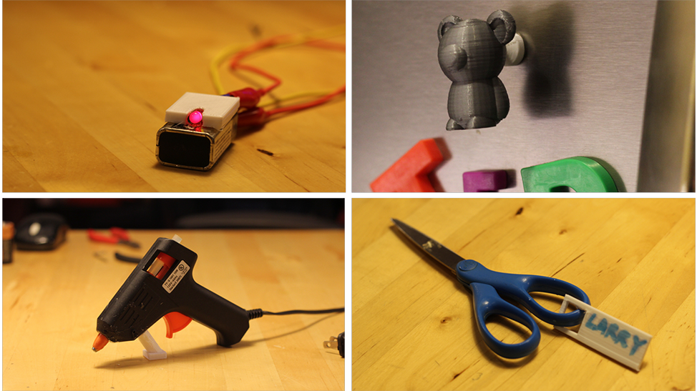

**a**

**b**

**c**

**d**

Figure 3.1: Examples of how existing objects can be augmented using our techniques: a) turning a battery into a LED torch; b) making a magnet from a Teddy bear; c) adding a stand to a glue gun and d) attaching a name tag to a pair of scissors.

These attachment techniques were integrated into Encore–a tool that can import a 3D model of an existing object, perform geometric analyses for the attachment techniques, and allow user exploration through visualization and direct manipulation. Our analysis metrics are designed to provide up-front information about viability, durability and usability of the attachments, where the user can explore tradeoffs among these metrics. Finally, Encore will generate a production- ready model of the parts to be printed, including information necessary for the custom printing process. Figure 3.1 shows an overview of the underlying framework.

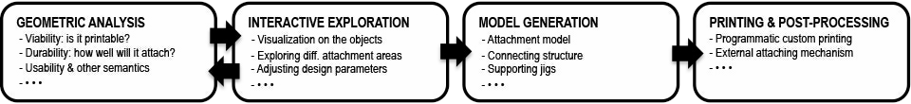

Figure 3.2: A computational pipeline for designing and fabricating attachments to augment ev- eryday objects.

In the remainder of the chapter, I first review existing attachment solutions and how they might afford end-user customization. Then I present the attachment techniques, describe several exemplar analysis metrics for evaluating the goodness of attachment, and present Encore’s vi- sualization and direct manipulation interface. Finally I report an evaluation of printing cost and strength.

## Existing Attachment Solutions

Attachment–fastening or otherwise binding two objects together–is a task that commonly arises in everyday life, and one that is not entirely straightforward. Material properties, strength, us- ability, and aesthetics all need to be considered when attaching objects together. To address this, websites like ThisToThat 1 let a person enter two materials and suggests the best option for glu- ing them together. Other approaches leverage objects’ mechanical properties, such as the widely used joineries and fasteners commonly used in various manufacture industries (e.g., [3]). Attach- ment can also be made complex by the specific constraints of the objects being connected. For example, the free universal construction kit2 offers adaptors between 10 otherwise incompatible children’s construction kits from Lego to Tinker toys.

In this work, we are primarily interested in attaching 3D printed components to existing objects. We assume that the existing object is not designed with attachment in mind, and is not to be directly modified (e.g., by drilling holes in order to use a bolt). Specifically, given an existing object and a new part we would like to fabricate and attach, we can either create a binding force between the new part and the old (such as using adhesives, or printing directly over a material that the filament will easily adhere to it) or in some cases we can loosely interlock the new part and the old (such as a buckling a strap through a handle or adding a charm to a charm bracelet or a key to a ring).

Choosing among these forms of attachment is a matter of understanding the task to be accom- plished and the constraints that come with it. For example, if we wish to add a doggie bag holder to a dog leash, we may want it to be removable, but not moveable once attached (so it doesn’t flap around too much). It must be sturdy enough to survive many walks, dropped leashes, and so on, but does not need to carry much weight (just a roll of plastic bags). It may need to attach just below the handle of a cloth leash, or perhaps we are designing one that can attach to the plastic handle of a retractable leash. As another example, if we wish to add a handle to an espresso cup, it should withstand sheer forces based on the typical weight of a cup. These examples clearly demonstrate the wide range of issues that must be considered, and the interaction of properties of the existing object, task, and object to be attached.

To summarize, to determine the goodness of an attachment technique, viability, durability and usability are all important, although their relative importance may vary. Keeping these issues in mind, our focus in this project is on attachments to, around, or through an existing object without modification by leveraging the fabrication process and customizability of 3D printing. Below I showcase three exemplary attachment techniques.

## Techniques For 3D Printed Attachment

Our techniques allow attachments to be printed directly onto an existing object (print-over), or separately and then adhered or strapped to it (print-to-affix), or through and around the object’s holes (print-through). Here we assume that the models of the existing and the new objects have

1<http://www.thistothat.com/>

2<http://fffff.at/free-universal-construction-kit>

been acquired using 3D scanning, or created from scratch, and focus on methods for attaching the two together.

### Technique #1: Print-Over

The first technique, print-over, is able to print an attachment directly onto the existing object. Once the attachment location is specified, the existing object is oriented and scaffolded with sup- port structures so that it will not move while the attachment is printed on it. It is also important to ensure that the existing object will not impede the motion of the print head while the attachment is being printed.

Figure 3.1b shows a magnet holder directly printed over a Teddy bear toy (in this case also 3D printed) to make it a fridge magnet. As shown in Figure 3.3a, this was done by scaffolding the Teddy bear to the print bed so that the attachment area is facing upward and is accessible by the extruder, which then prints the magnet holder.

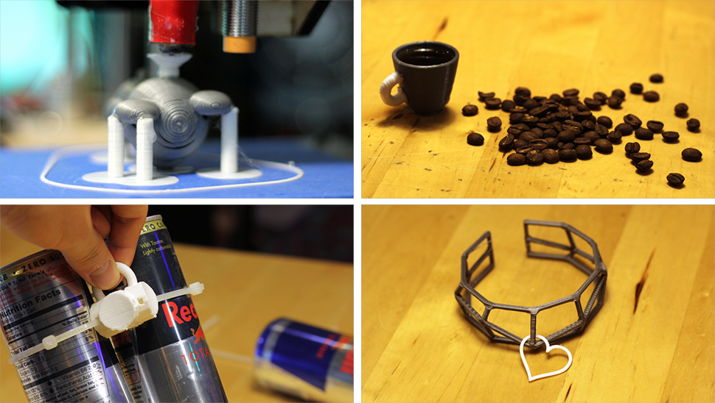

**a**

**b**

**c**

**d**

Figure 3.3: a) The magnet holder printed directly on a teddy bear that was scaffolded on support structures; b) a handle added to an espresso cup; c) strapping to make a reusable 4 pack handle; and d) a bracelet printed through a heartshaped charm.

Print-over works well when the attachment and the existing object are made of the same ma- terial, or materials that share similar thermodynamic properties. As detailed later, our evaluation shows that print-over is strong enough to sustain stress as if they had been printed in one piece. When objects are made of less compatible materials, we employ a work-around to perform print- over. Figure 3.1a shows an LED casing printed directly over a 9V battery to make a simple torch. This was done by adding a thin layer of glue on the battery prior to printing the casing. The glue simply creates a plastic-like layer that allows the printer’s material (PLA) to stick to the battery while being printed.

### Technique #2: Print-to-Affix

The second technique, print-to-affix, makes use of the concept of a connector that confomrs to the surface geometry of the existing object and is snug-fit to the new object. This connecter can be printed separately and then attached using external mechanisms (e.g., glue, or straps). This leverages the customizability of 3D printing to bridge objects and attachments that by default are likely to have unmatching surfacing. Figure 3.3c shows connectors used for the handle at- tachment to hold it tight with cans. Print-to-affix is a very general technique and can encompass for example the use of adhesive, straps, or even a custom printed part that snaps into place in some way. It also has the advantage of not preferring the existing object to be flat, as there is no concern about the print head colliding with the existing object.

Figure 1c shows a structure added to a glue gun to make it stand. This geometry was made to precisely match the attaching part on the glue gun, then 3D printed, and attached using adhesive. However, one disadvantage of using adhesive (or the aforementioned print-over) is the difficulty in detaching the attachment for redesign or reuse. Affixing with straps solves this problem. For example, using straps for the ‘4 pack’ holder in Figure 3.3c makes this handle reusable without either breaking it or the cans it holds.

Print-to-affix includes a wide variety of options. Details such as whether adhesives or straps are used significantly change the properties of the resulting attachment. For example, in one experiment, a 150mm zip tie could sustain up to a 4kg pulling force before the test object slipped, while the particular adhesive we applied tended to break at a less than 1kg force. On the other hand, using adhesives is less noticeable from an aesthetic standpoint.

### Technique #3: Print-through

The third technique, print through, leverages the structural holes in some existing objects (e.g., keys and rings) to print the attachment through and around it. To accomplish this, the attachment is partially printed, the existing object is placed, and then printing continues until the two objects are interlocked and the print is complete. This requires determining whether there is a viable point at which to stop the print, and whether once the existing object is placed it will interfere with the print head.

Figure 3.1d shows a name tag printed through the handle of a pair of scissors. As shown in Figure 3.4, this was done by programmatically pausing the printer at a point where the scissors can be placed down and out of the way of the print head. Print-through has aesthetic qualities that distinguish it from print-to-affix and print-over: it typically creates a loose but permanent connection between two objects. Figure 3.3d is another such example whereby a bracelet was printed through a charm.

As highlighted in the techniques just presented, a range of tradeoffs must be considered when creating 3D printed attachments to existing objects. To address this, we present a series of analysis, based on the geometric properties calculated over the triangular meshes representing the existing object and the attachment. These analyses represent a sample of metrics that pertain to viability, durability, and usability. However, it is our intent and expectation that this set would be expanded over time and as new attachment techniques are explored.

* + - * *Viability* indicates whether it is possible for a new part to be fabricated and attached at

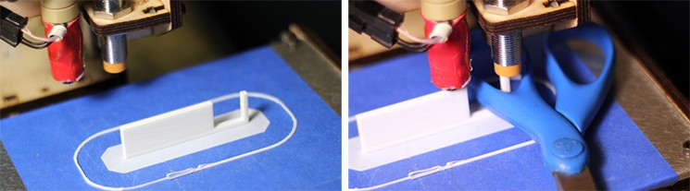

**a**

**b**

Figure 3.4: Example of a print-through process: the printer pauses at a point where the scissors can be dropped to interlock with the name tag, after which the print job resumes.

a given location on an existing object. For example, collision with the extruder during a direct print over process would violate viability;

* + - * *Durability* examines how the geometric properties of the contact area between the attach- ment and the object could potentially strengthen or weaken the bond between them;
      * *Usability and other semantics* considers various issues related to the actual usage of the at- tachment, such as the forces we expect to be applied to it, its balance, and some technique- specific issues (such as the length of strap required for fastening an attachment).

The next section will describe the details of these analyses, which serve as the computational backend of Encore—an interactive tool that informs people how attachments can be added to existing objects and how well they will perform in terms of viability, durability, usability and other semantics.

## Geometric Analysis: Viability

Viability can encompass issues such as appropriateness for a specific printer with regard to issues such as support or size, as well as feasibility of printing without collision when an existing object is present during printing. Our work focuses on this last issue, which arises during print-over and print-through. More specifically, when printing involves two objects, it is only viable if *(i)* the attachment can be printed without the extruder’s tool paths colliding with the existing object (extruder-object collision); *(ii)* the attachment and the existing objects also do not intersect and collide with each other for a given spatial configuration (object-object collision). As shown in this section, both types of collisions are affected by the position and orientation of the existing object and the attachment. Thus, we must determine a position and orientation of both objects where the attachment can be printed collision-free.

### Understanding Viability: Collision Detection

The first step of viability analysis is to detect collisions that will prevent the attachment from being printed.

#### Detecting Extruder-Object Collision

Extruder-object collision occurs when the placement of the existing object impedes the printer’s extruder movement while the attachment is being printed. This type of collision problem is very common in subtractive manufacturing and is often solved by careful tool path planning [13,](#_bookmark160) [32], such as controlling the path of the cutting bit on a CNC router to avoid running into parts that are not to be removed. WirePrint has shown that collision can be avoided in non-layered additive manufacturing by modeling and considering the geometry of the extruder and the object [38]. In print-over, given an attachment Λ to an existing object Ω, we scan all Ω’s’ vertices above the attaching point to detect whether they are within the range of the extruder’s movement, which can be obtained by computing the bounding radii of both the extruder and Λ.

#### Detecting Object-Object Collision

We consider and address two forms of object-object collision between an attachment and an existing object.

**Direct Collision**. In an interface for attachment placement, the mapping of the 3D scene onto a 2D screen could cause user errors in the placement of Λ with respect to Ω. A user might perceive Λ as interlocking with Ω, and yet the two in fact slightly intersect with each other, such that Λ is unable to be fabricated (Figure 3.5).

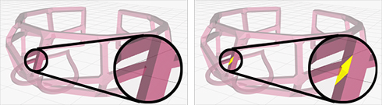

**a**

**b**

Figure 3.5: Print-through provides visual feedback (highlighting intersecting faces) to inform users of object-object collision that might not look obvious from certain viewing angle.

Such direct object-object collision is commonly dealt with using approximate models (e.g., checking axis-aligned bounding boxes for collision [5]). Such models could be problematic for attachments: for example, in print-through, Λ and Ω can be interlocking and collision free even though their bounding boxes do intersect with one another.

To address this, we compute whether two objects truly intersect by analyzing their meshes. To narrow down the detection scope, we compute both Λ and Ω’s bounding spheres and locate a set of mutually bounded’ faces from Ω, denoted as *F* Ω. Essentially, Λ and Ω are intersection free if and only if none of *F* Ω’s faces intersect with Λ’s. By walking through a pre-computed octree of Λ [36], we can determine if a given face of *F* Ω intersects with Λ. Further, as detailed later, we can also visualize the intersecting areas to inform the users how to reposition the attachment to an occlusion-free location (Figure 3.5).

**Indirect Collision**. When objects need to be placed around or through another object (e.g., a partial print), indirect collisions can occur. For example, viability is violated in print-through

23

July 30, 2016 DRAFT

if one object cannot be moved to its intended interlocked position without passing through’ (i.e., intersecting) the body of the other object.

Figure 3.6 shows an artificial print-through example to explain this problem. In Figure 3.6a, the existing object (the torus) cannot be inserted into the larger structure (building layer by layer in the direction of the arrow) no matter when the printer is paused. Note that as illustrated in Figure 3.6b, indirect collision is orientation dependent there might exist an orientation that does provide a viable print for some pause point, different than the one specified by the user for analysis.

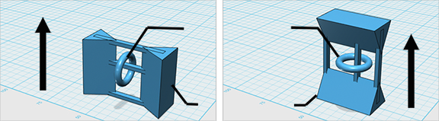

**a**

**to be inserted**

**b**

**to be printed**

Figure 3.6: Interlocking objects are not always viable for printing: a) the torus cannot be inserted while the structure is being printed due to collision; b) a different orientation makes the print viable. (arrows indicate printing directions).

Inspired by Zhou et al.’s use of physics to unfold an object so as to test whether it can be folded [91], we make use of a reverse physics simulation. Specifically, we test whether there is a viable path for moving the existing object to its desired location (e.g., the scissors in Figure 3.4) partway through the print of the new object. We test such viability by reversing the insertion process. It starts with an object already inserted into the partial print, which is obtained by slicing the whole print so that its top layer is just above the inserted object. Then gravity is reversed. If the object ‘escapes’ under the reversed gravity, there exists a path for it to be inserted back from above and end up at the same placement where the test started.

In cases where this test fails (i.e., the object is trapped in the partial print), we can also perform a binary search to find a viable printing orientation, which we discuss next.

### Attaining Viability: Resolving Collision

Once collision is detected, our analysis also searches for a solution by exploring alternate posi- tions and orientations.

#### Resolving Extruder-Object Collision

Extruder-object collision is only an issue when printing an attachment Λ after an existing object Ω has been placed. Given a candidate surface area *S* of Ω on which Λ is to be printed, the first step is to rotate Ω so that *S* is relatively level and facing upward for extruder to print Λ on (e.g., the Teddy bear in Figure 3.3a). Generally *S* is not a perfectly flat surface to print on, so our next step raises Λ’s first printing layer *P*0 to be above the entire *S*. However, after these two

24

July 30, 2016 DRAFT

operations, printing Λ might still run into object-extruder collision if parts of Ω are also above *P*0. To address this issue, we first print a connector on *P*0–a cylindrical structure that is small enough to be printed without collision. These connectors serve to continue raising the starting layer until Λ can be printed collision-free. One potential issue of this approach is the strength of these connectors in supporting Λ, which we also discuss later in the durability analysis section. Even with these solutions, some surface areas, such as those with a high convexity, might still be unprintable. As detailed later, our exploration phase (Figure 3.2) visualizes this information to guide the user in selecting alternate viable attachment areas.

#### Resolving Object-Object Collision

For object-object collision, a search for the position and orientation of Λ can determine whether there is a viable solution (in which the reversed gravity’ test succeeds). A simplified example of this situation is shown in Figure 3.6, where rotating Λ by 90 degrees resolves the issue.

Formally stated, the goal is to find a pair of rotations (*α, γ*) such that there exists a viable pause point for *Rx*(*α*)*Ry* (*γ*)Ω. (*Rx* and *Ry* are rotation matrices around *x* and *y* axis, respec- tively; rotating around *z* axis would not change the viability). The solution space is naturally

continuous: given an pair of viable (*α*ˆ*, γ*ˆ), there must also exist intervals *αl < α*ˆ *< αu* and

*γl < γ*ˆ

*< γu* such that any printing direction in *{*(*α, γ*)*|αl < α < αu, γl < γ < γu}* is also

viable. Our search process is akin to a binary search of such intervals.

To sum up, the viability analyses described above detect collision issues that arise while fabricating the attachment either with the extruder or the existing objects. To prevent collision, we can orient the object or raise the starting layer. We also show that a collision-free printing orientation belongs to a continuous solution space and can be found via a binary search.

## Geometric Analysis: Durability

Once a new part is viable for fabrication, the next question is its durability: how well it will attach to the existing object. One simple way to measure durability is to consider the contact area *S* between the existing object and the attachment; however our framework is extensible to other models and methods such as the cross-sectional analysis [73] and Finite Element Method [65]. Specifically, given a candidate contact area *S*, we consider the following metrics.

#### Size

Size can be approximated by summing up the area of each triangle in or intersecting with *S*. To generalize to multiple attachment sizes, we normalize the measurement by the volume V of the attachment. This metric serves as a simple way to capture an approximation of the structural strength of the connection point with respect to the attachment.

#### Flatness

Flatness can be computed by summing up the vertex-wise distance between *S* on the existing object and the printing layer at the bottom of the attachment. The flatness score is highest when *S*

25

July 30, 2016 DRAFT

is perfectly flat (coplanar with P); and lower as *S* becomes more irregular, meaning the triangles in *S* have highly variable heights and orientations, or *S* has an overall higher curvature.

#### Direction and Area of Force

The relationship between force and strength is affected by the type of attachment being used. For example, techniques such as print-over and using adhesives use interfacial bonds, with adherence to both the existing object and the attachment. In contrast, attachment techniques such as strap- ping create a force that holds the attachment onto the existing object, which can be measured as follows.

Consider an attachment surface *S* on the existing object for a strap, we compute *S*’s convex hull *ConvHull*(*S*) using a Graham scan [22]. For each point p in *S*, we compute its shortest distance to *ConvHull*(*S*): if the distance is smaller than a threshold we consider p to be making contact with a strap around *S*. The object is more strappable at *S* if most of *S*’s points make con- tact with the strap. A further consideration is contact point distribution: more evenly distributed contacts suggest a more balanced strapping force.

To sum up, durability examines how the geometric properties of the contact area between the attachment and the object could potentially strengthen or weaken the bond between them. Our analysis shows how contact area and size can be used to compute durability (most usefully for adhesion-based attachments) and explores the metric of strappability, which captures the contact area and force associated with a strap.

## Geometric Analysis: Usability & Semantics

Even for a new part that is viable and durable, there are often further considerations related to the actual usage of the attachment. We provide two exemplar analysis of usability and semantics:

*(i)* for handle-like attachments, we consider whether its attachment point creates a balance of the entire object when being gripped or held; and to illustrate a metric which is highly specific to one attachment technique *(ii)* an aesthetic strap length metric.

It is only natural that the analysis of usability and semantics would be highly specific to the type of attachment being used. For example, Pre´vost et al. discuss geometric modifications that can achieve balance such that an object will stand without falling [47]. Thus, the metrics we present are by no means exhaustive for the usability and semantic aspects of attachments; rather they suggest exemplar analysis that goes beyond the stage of fabrication and considers the effects and tradeoffs for an attachment in use.

#### Balance When Holding an Object By the Attachment

Balance when holding an object by a given attachment can be measured by moment, which indicates the tendency of the held object to rotate under its own weight. For example, as shown in the 4 pack’ holder in Figure 3.3b, if the handle is rotated 90 degrees, it would be more difficult to hold the cans. When there are multiple contact points selected (such as the handle on an espresso cup), we simply sum up the moments of these points before normalization.

26

#### Technique Dependent Usability Analysis: Strap Length

Some attachment techniques may make use of very specific usability analysis. For example, the length of the strap is directly related to fastener cost and object appearance. In particular, we consider an analysis of strap length for a candidate attachment configuration normalized to a baseline (e.g., the bounding sphere of the existing object). The strap length can be computed from the aforementioned convex hull of the strapping area.

## A Pipeline For Printed Attachments

We have presented a series of geometric analysis that can be used to quantify the goodness of various potential attachment options from the perspective of viability, durability, and usability. As shown in Figure 3.2, analysis results can be integrated into a pipeline for supporting itera- tion, interactive exploration, model generation, printing and post-processing. We illustrate these phases of the pipeline with our implemented tool, Encore.

### Interactive Exploration

The interactive exploration phase creates a feedback loop wherein a user can explore different design parameters. Encore provides visualization and direct manipulation techniques to facilitate this process.

#### Visualization Techniques

Visualization provides effective feedback to the users to inform them about properties of their own design. When making attachments, one type of visualization is to compute an attachment score for each point on an existing object and overlay the results as we render the 3D model. Specifically, for each face on the object’s mesh, we locate its neighborhood area *S*, and pre- compute the viability, durability and usability analysis for this area. The results from different analyses can be weighted and combined based on user input and the purpose of the attachment.

Figure 3.7 shows Encore’s heat map visualization of these computed values, rendered on a wrench where the user would like to use print-over to add a handle (e.g., for hanging the wrench from a machine that needs frequent maintenance). The red areas indicate the parts of on the wrench where a handle cannot be printed over due to unavoidable occlusion (Figure 3.7a). The user can adjust the weights given to the metrics, such as choosing to emphasize durability. The visualization is interactively updated and shows preference (green) for areas with small curvature (Figure 3.7b). Alternatively, the user can emphasize balance, which narrows down the preferred areas to those near the center of mass (Figure 3.7c).

#### Direct Manipulation Techniques

Some attachment techniques, such as strapping, might require more user direction. For example, Figure 3.5 shows in the print-through technique, how the user can position the existing object to interlock with the attachment. When the two meshes intersect with one another, the intersecting

27

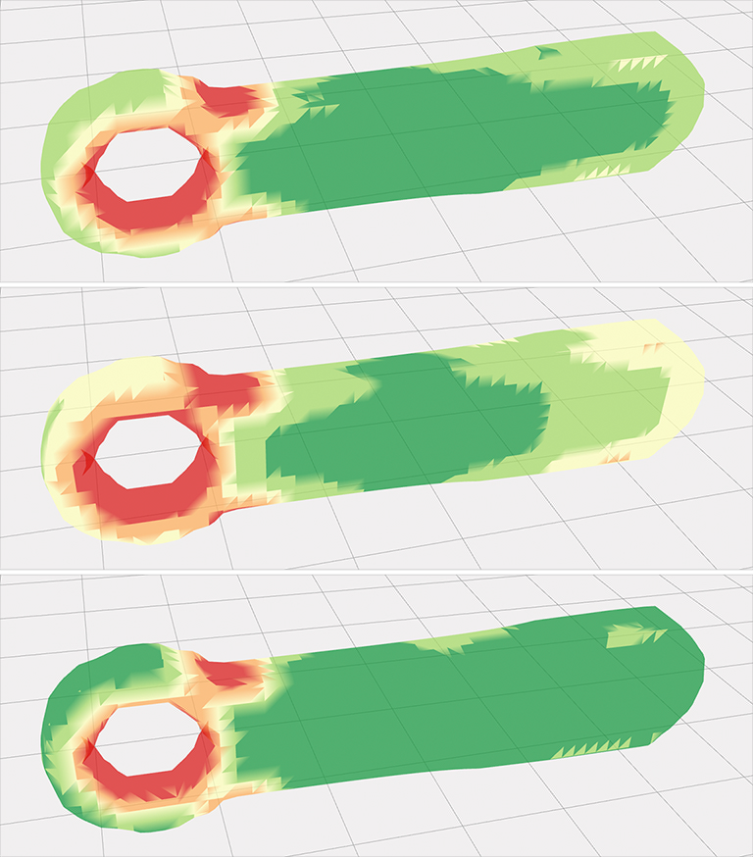

**a**

**b**

**c**

Figure 3.7: A heat map is an effective way to visualize the analysis results for adding a handle to a wrench: a) red areas indicate a handle cannot be printed over (viability); b) emphasizing durability shows preference for areas with small curvature; and c) emphasizing balance (usabil- ity) shows preference for areas near the center of mass (This assumes the forces applied have the same direction as the surface normals).

area is highlighted, which prompts the user to reposition the object to an intersection free loca- tion. Another useful technique is to allow the user to draw on the existing object to specify the attachment area. For example, for affixing using straps, the user simply draws a stroke around part of the object to indicate a strap. Based on this partial strap, we can find the corresponding cross section by first finding a plane that best fits the stroke points, and then intersecting the object with the plane. Figure 3.8 shows an example of drawing to specify where to strap an attachment on a bottle.

### Model Generation, Printing and Post-processing

Once the user is satisfied with the attachment location, the pipeline continues to the last two phases: model generation, and printing and post-processing.

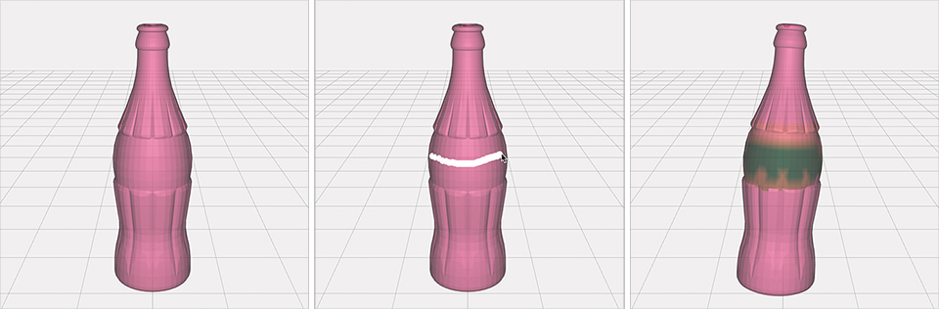

**a**

**b**

**c**

Figure 3.8: Directly drawing on the object is a simple way to specify the attachment area, such as drawing a stroke around a bottle (a, b) to indicate where to attachment a strap. (c) a heat map visualization around the selected cross section.

#### Model Generation

Model generation outputs a single file that includes the attachment, connector(s) and support structure. In particular, as discussed earlier, the connectors can raise the starting layer for printing the attachment to avoid potential occlusion issues; or be designed to snug-fit the existing objects (thus enabling affixing using adhesives or straps).

For some techniques, adding support can also solve occlusion problems. For example, in the print-through technique, when the attachment is much smaller than the existing object, it needs to be raised by a support structure so that the object can go through it while staying below the extruder. Other techniques use support to hold an object in place, such as direct print-over.

Figure 3.9a shows a connector and the support structure for printing over a magnet holder on a Teddy bear (the same one shown in Figure 3.3a). In this case, the five support cylinders at the bottom hold the bear in place and at the right orientation and have been prepared to exactly conform to the surface of the bear.

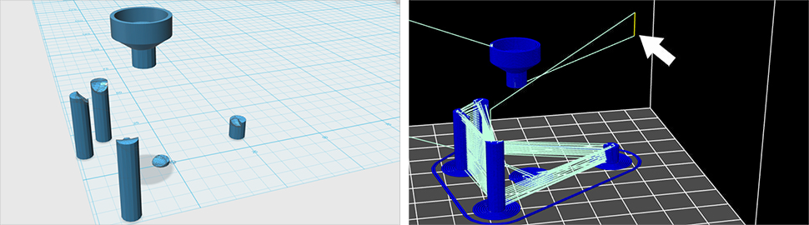

**a**

Figure 3.9: In the Teddy bear magnet example, a) a model is generated with a magnet holder, a connector, and the support structure; b) Tool path view in Repetier-Host: the extruder pauses and moves away for inserting the teddy bear (c).

#### Printing and Post-Processing

In the last phase, the user imports the generated models into the 3D printing tool chain for fab- rication. Some attachment techniques require a simple customization of the printing process, which can be programmatically achieved using 3D printing software such as Repetier-Host3 (Figure 3.9b). For example, both print-over and print-through require pausing the printer, insert- ing the existing object, and then resuming the print job. Having computed the pause point in the analysis, we can generate commands to perform these operations, such as:

G1 X0 Y0 ; move the extruder away G1 Z40 ; raise the extruder

@pause ; pause the print for insertion

; print is manually resumed here after insertion G1 Z31.550 ; restore extruder’s height

Figure 3.9c shows the extruder’s tool path as a result of these few extra commands. The extruder makes room for the Teddy bear to be positioned onto the support structures. It then returns and finishes printing the magnet holder.

Finally, some techniques require a few post-processing steps after the attachment is fabri- cated, such as applying adhesives or straps to affix a new part that is printed separately from the existing object.

### Software and Hardware Implementation

We have applied a computational framework–geometric analysis, interactive exploration, model generation, printing and post-processing supporting all three attachment techniques in Encore. Encore was implemented in JavaScript primarily using three.js4–a library for programming with WebGL. All the attachment examples were fabricated by an FDM printer made from Printrbot’s Simple Maker’s Kit5 . We used Slic3r6 for G-code generation, Repetier-Host for communicating with the printer, and 1.75mm PLA as printing material in all our examples.

## Evaluation

Below we report on an evaluation of our attachment approach from two perspectives: *(i)* to evaluate the printing process, we compare the cost of time and material for each technique; *(ii)* to evaluate the reliability of the printing results, we tested print-over and print-to-affix techniques, which rely on extrinsic adhesion ir fastening. Specifically, for these techniques, we investigate how well a fabricated handle can sustain forces that typically occur when holding, carrying and controlling an object.

3<http://www.repetier.com/> 4<http://threejs.org/>

5<http://printrbot.com/shop/simple-makers-kit-2/> 6<http://slic3r.org/>

### Evaluating Time and Material Cost

One potential benefit of printing to augment existing objects rather than creating new ones is to spend less time and material printing. To verify this, we compare the printing plus process- ing time and material cost between our attachment techniques (print-over, print-to-affix, print- through) and a baseline approach, which prints a brand new object that has the attachment as an integral part of it.

#### Cost Prediction Model

As shown in Table 1 and Table 2, by the nature of different attachment techniques, we can predict how they differ in printing time and material cost.

Printing time is broken down to time spent on actual 3D printing (T) and time on handling or post-processing (t). For example, print-over requires the printing of the attachment, connector(s), and support structure; it also takes time to insert the existing object to be printed over, as well as to apply adhesives to increase the firmness of the scaffolding.

Material cost is split between printing the attachment and other structures. For example, print-through might also require support structures to keep the interlocking object collision free, even if the attachment itself does not have overhang problems. For the baseline technique, print- ing time and material is spent on a new object made of the original object combined with the added attachment.

Table 3.1: Prediction models for printing time of attachment techniques and data from a exemplar object+attachment.

|  |  |  |  |
| --- | --- | --- | --- |
| **Technique** | | **Prediction model for time** | **Case study:**  **Utah teapot** |
| Print-over | | *Tattachment* +*Tconnector* +*Tsupport* +*tinsert* +*tapply adhesive* | 31:41 |
| Print-to-Affix | Adhesive | *Tattachment* + *tapply adhesive* | 13:56 |
| Strap | *Tattachment* + *tstrap* | 11:27 |
| Print-through | | *Tattachment* + *tinsert* | 19:43 |
| Print as one piece | | *Tattachment*+*object* | 1:13:13 |

Table 3.2: Prediction models for material cost of attachment techniques and data from a exemplar object+attachment.

|  |  |  |  |
| --- | --- | --- | --- |
| **Technique** | | **Prediction model for time** | **Case study:**  **Utah teapot** |
| Print-over | | *Mattachment* + *Mconnector* + *Msupport* | 916mm |
| Print-to-Affix | Adhesive | *Mattachment* | 402mm |
| Strap | *Mattachment* | 396mm |
| Print-through | | *Mattachment* + *Msupport* | 582mm |
| Print as one piece | | *Mattachment*+*object* | 3054mm |

#### A Case Study

We verify these intuitions in a concrete attachment case: adding a torus-shaped handle to the Utah teapot. We chose the Utah teapot because it is a classic 3D model and because it is also one of the few widely used 3D models where all of our techniques are applicable. The results are shown in Table 3.1 and Table 3.2.

The goal of this evaluation is to reveal how time and cost differ between various techniques, rather than to obtain a ‘true’ value through repetitive trials. As such, we used the slicer program (Slic3r) to estimate printing time and material cost. This program calculates time and cost as it analyzes the input models and generates the corresponding G-code. For techniques that require handling or post-processing, such as applying adhesive, we empirically estimate the time. The particular adhesive we chose (Loctite Professional Heavy Duty Epoxy Loctite #1172794 requires 5 minutes of ‘setting’ time, while strapping usually takes no longer than 3 minutes.

Both the prediction model and case study results support our intuition–when support is needed, time and materials go up; and the baseline condition is dominated by the time needed to print the existing object.

To better understand the tradeoffs, we conducted another evaluation to test the general strength of our print-over and print-to-affix, also compared to the same baseline (an integral print of existing object and attachment). Print-through is often done loosely without binding between surfaces. Thus strength issues for print-through are directly related to the objects themselves, rather than the attachment technique. Similarly, print-to-affix using adhesives depends heavily on properties of the adhesive used. As such, no testing was performed for these two techniques. We report on print-over and print-to-affix using strapping.

### Evaluating Strength of Printed Attachments

The goal of this evaluation is to understand the tradeoffs and limits of our techniques in com- parison to each other. We tested a type of attachment handles, as they are likely to experience external forces, such as holding, gripping or pulling. For each attachment technique tested, we fabricated handles using the same printer and material as described earlier. Similar to [73]’s test of printed objects’ cross sectional strength, we exerted a bending force tangential to each handle’s attachment point (pulling the handle sideways at 90*◦* with respect to its main axis, as illustrated in Figure 3.11). We then gradually increased the force and measured the point of fracture [69].

#### Evaluating Print-Over Attachment

For testing print-over attachment, we designed a torus-shaped handle with fixed outer radius of 7.5 mm and inner radius of 2.0 mm. We empirically set these values to match the size of human fingers. Larger scales of handles are much more time-consuming to fabricate and might go beyond the dimension limit of our printer. Thus we leave them for future work.

We then computationally generated a series of 20mm by 20mm by 5mm platforms whereon to fabricate the torus handles, connected via a cylindrical connector (radii: 1.5mm, height: 3mm). Next we modified the top surfaces of these platforms: the independent variables are the

Curvature and Roughness of these top surfaces.



pulling force

attachment attaching surface

Figure 3.10: To test print-over in comparison to printing in one piece, we used both techniques to print attachments on surfaces with varied curvatures and then exerting tangential pulling force.

* + - * Curvature. Assume *R* is the radius of a platform’s top spherical surface and *r* is the ra- dius of the cylindrical connector of the handle. We modeled the curvature by *C* = *r/R*. Specifically, we tested on *C* = 0 (a flat surface), 0.25, 0.5, and 1.
      * Roughness. We performed Boolean subtraction operation between the platform’s top sur- face and a pre-set number *N* of small spheres whose centroids are on the surface, positions randomized, and radii randomly distributed in [0.25mm, 1mm]. This made the surface porous, thus creating roughness. We tested on *N* = 0 (smooth surface), and 10 (rough surface).

We fabricated the platforms and handles under these conditions using print-over and the baseline print-in-one-piece approach.

As shown in Figure 3.11, we clamped the platform firmly onto the top of a table so that the handle was pointing upward. We then used a handheld scale to hook and pull the handle horizon- tally. We used a slow uniform motion for increasing the force. The process was videotaped to capture the scale’s reading at the moment when the handle fractured or detached. We performed three trials for each condition.

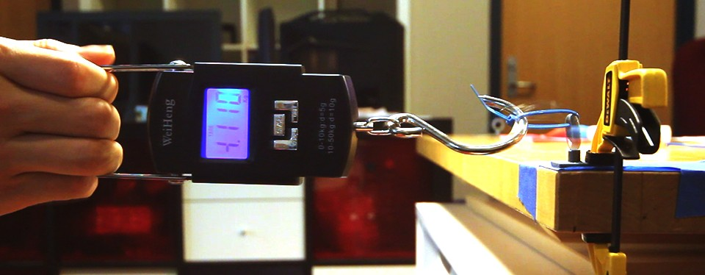

Figure 3.11: Testing the strength of a 3D printed handle attachment (b) by clamping it on a table

(c) and pulling using a scale to measure force (a).

Figure 3.12 shows the results of the strength test: overall print-over’s best performance was close to that of the baseline. However, it suffered from an increase of surface curvature (Fig-

33

ure 3.12a) and roughness (Figure 3.12b).

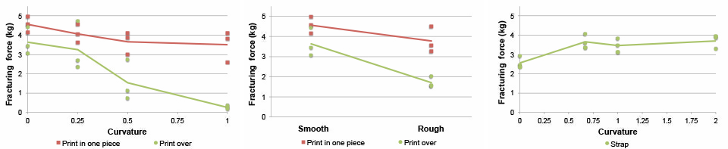

**a**

**b**

**c**

Figure 3.12: Strength test results show print-over is strong enough to sustain stress as if they had been printed in one piece. Both our techniques suffer from an increase of surface curvature (a) and roughness (b); (c) shows that affixing with straps (150mm zip tie) is able to sustain over 2.5 kg of pulling, and reacts differently to curvature.

Affixing using adhesion is also related to this evaluation. However, its performance is hard to test in a general way, as it strongly depends on the particular types of adhesives used, as well as the user’s experience and expertise of handling it. Therefore we leave it as future work.

#### Evaluating Strapping-based Attachment Techniques

Using straps requires a different analysis than print-over. The key question for strapping is how likely the object is to slip’ through the strap when pulling forces are exerted. This is a potential issue that does not occur with the baseline and adhesive attachment mechanisms. Thus we tested this affixing technique independently of the other attachment options.

Specifically, given the same cross section *S* (we use a circular *S*), we are interested in whether and how the curvature perpendicular to *S* affects ‘strappability’. To test this, we computationally generated a series of olive-shaped objects created by revolving a circular segment (with radius

*R*) around its secant. We computed the secant so that the revolved shape had a cross section of radius L/2. We then symmetrically cut off the two ends of so that the remaining pieces have a uniform length of *L*.

We quantified curvature as *C* = *L/R*. We tested *C* = 0 (a cylindrical lateral area), 0.67, 1, and 2. For each object, we generated a handle attachment using Encore, and then fabricated it and strapped it around the center of the object using a 150mm zip tie. We then firmly clamped the handle to a table and then pulled on the strapped object, measuring the minimal force required to pull the test object out of the strap using a similar setup as the previous test (Figure 3.13).

Figure 3.12c shows the test results. Depending on the curvature, a 150mm zip tie attached using our approach can sustain a pulling force of from 2.5 to 4 kg without letting the object slip. Interestingly, strapping strength improved with increased curvature (Figure 3.12c), in contrast to other attachment methods (Figure 3.12a).

34



pulling force

attachment attaching surface

Figure 3.13: To test strapping in print-to-affix, we increased the curvature between the attachment and the attaching surface and exerted tangential pulling force.

## 3.8 Summary of Attachment Techniques

Although the tested attachment techniques were developed using the same framework, our per- formance testing demonstrates that they have their own unique advantages and weaknesses. A limitation of our evaluation is its focus on 3D printed existing objects. In this discussion we pro- vide some anecdotal intuition about other factors that might affect the reliability of attachments fabricated by our techniques. Further, to better understand these techniques as a whole, we also discuss some practical issues in comparison with one another.

Print-over, as shown in our evaluation, creates strong adhesion between attachments and ob- jects that are made of the same or very similar material. It also requires no post-processing. However, it has weak adhesion on some materials. For example, when making the LED torch (Figure 3.1a), our initial attempt to directly print on the metal shell of the battery was not suc- cessful. The problem was eventually solved by the simple addition of a thin layer of glue on top of the battery shell. We expect that the use of a glue layer will show promise in other situa- tions as well, but substantially more experimentation and testing is required before its range and properties can be precisely understood.

Affixing with adhesives is widely applicable to a range of geometry and material. But it re- quires good selection of adhesives, and in some cases careful handling of the amount and mixing of ingredients in order to achieve the best adhesion. Compared with the other techniques (e.g., print-over and print-through), affixing with adhesives relies perhaps the most on the expertise of the users.

Affixing with straps is easily adjustable and also makes an attachment reusable. However, it could be less aesthetically desirable for some use cases. Surprisingly, within the range of our tests, as curvature increased strapping attachment became stronger, whereas all other techniques became weaker. We hypothesize that when the interface between the existing object and the com- pliant strap has higher curvature, it requires more deformation of the strap in order for the object to slip. Thus the strap can sustain a higher pull force when the curvature increases. However, this hypothesis requires more investigation.

Print-through is a natural attachment mechanism that requires no adhesion or fastening. How- ever, it has limited scope of use as only some objects have appropriate holes or loops that are required to perform this technique.

Despite its increasing popularity, 3D printing has been used almost exclusively to create objects ‘from scratch’, rather than leveraging things that already exist in our day-to-day life. In this project, we present a framework for using 3D printing to augment everyday objects, and

provide specific analytical and computational support for realizing one approach of augmentation adding functional attachments to existing objects. Our framework encompasses key aspects of attachment including geometric analysis, interactive exploration, model generation, and printing and post-processing support. In particular, we present an extensible set of analytical techniques, all based on the geometric form of the existing object and the proposed attachment, and range from very general print viability issues, to durability issues, to very specific usability issues.

There are several remaining questions that require further investigation. Foremost, are there any other attachment techniques that can leverage the use of a 3D printer? Are there any new perspectives that could be introduced into the analyses? Are there any specific use of adding attachments to existing objects that might require further computational support? In my next project, I focus on exploring the third question: I go from developing attachment techniques to enabling the design of functional attachments that can adapt real world objects for custom use.

Another question is given these attachment techniques, how we can design add-on compo- nents so that they can serve to augment an object in user-customized ways. My next chapter answers this question through the exploration of designing 3D printed adaptations—components that mechanically enhance or repurpose an existing object.

**Chapter 4**

**Adapting Real World Objects for Custom Users and Use Cases**

In our everyday life, we often find a need to adapt objects or tools, as the way they were originally designed might not work for certain users or use cases. For example, a faucet might be out of reach for a child, thus it needs to be extended1 (Figure 4.2a); it is hard to hold a drill bit straight while sharpening it, thus a guide comes in handy to keep it in place2 (Figure 4.2b); painting a big surface with a spray-can could be fatiguing for the fingers, thus a mechanism can be used to turn it into a spray-gun3 (Figure 4.2c). These add-on components are called *adaptations*. Adaptations change the mechanical properties of existing objects to make them more accessible or to customize them for specific use cases.

The advent of low-cost 3D printing offers the possibility to rapidly construct a wide range of adaptations. However, designing or re-purposing adaptations is hard with general-purpose 3D modeling software, as it requires a certain level of expertise from users [25]. In general, 3D modeling tools do not take into account how an object is used, what adaptation strategy is available, or how to rapidly generate the corresponding geometry or further customize it.

Prior work, such as Patching [67], Encore [11] and AutoConnect [30], mostly focuses on attaching or directly fabricating new components onto existing objects. However, it remains unclear how to design these components so that they can serve to adapt the objects in user- customized ways. P.Pod [16] and RetroFab [48] explored the mechanical problem of hijacking and automating controls on existing physical interfaces. However, such mechanisms are usually too heavyweight for adapting common household items and hand tools.

In this chapter, I build on previously explored attachment techniques, and develop a design tool for specifying, generating, customizing and fitting 3D printable adaptations onto everyday objects. My particular focus is on empowering end users to leverage new fabrication technolo- gies to create adaptations by providing high-level techniques for specification and computational support for geometry generation.

Reprise allows a user to specify how an object is used and with what types of action, such as using a virtual hand (Figure 4.1b) to indicate how a person would hold a wire cutter. As 3D

1<http://peachyco.com/handleextender.html>

2http://www.thingiverse.com/thing:1024834 3http://www.thingiverse.com/thing:51966

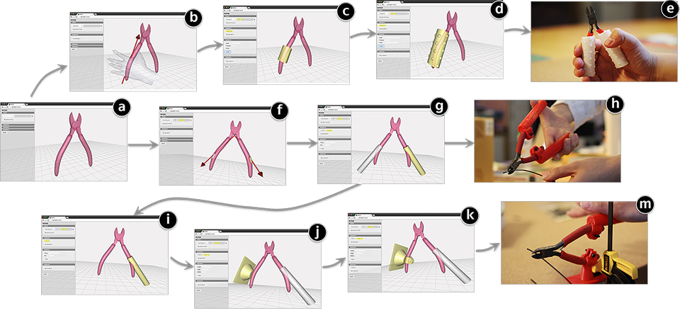

Figure 4.1: Our main contribution is the tool integration and a formalized design workflow for making 3D printable adaptations onto everyday objects. For example, an occupational therapist can use our tool to explore different strategies of adapting a wire cutter (a), such as creating a wrapper to soften the grip (b-e), adding two levers to assist with clutching (f-h), or replacing one lever with an anchor to situate the cutter on the work surface (i-m).

geometry itself does not encode how an object is used in the real world, Reprise’ techniques enable a user to interactively describe this information *in situ* on models of the objects.

Once the actions are specified, this information is fed into a library of design strategies– Wrapper/Extension, Handle, Lever, Anchor/Stand, and Guide (Figure 4.3). These adaptation strategies were derived from an analysis of over 3000 lifehacking and assistive technology ex- amples found in three books [46,](#_bookmark193) [51,](#_bookmark198) [87] and two online communities [44,](#_bookmark191) [70]. A user can select one or more strategies, which automatically generate the initial design of an adaptation, such as a wrapper for a cutter’s handle (Figure 4.1c), levers for easing clutching operation (Figure 4.1g), or a structure to anchor the cutter for situated use (Figure 4.1i).

To further iterate on the design, a user can manipulate simple slider widgets to customize these adaptations to better suit the person’s needs and preferences, such as making the cutter’s wrapper longer and thicker for easier gripping (Figure 4.1d), increasing the levers’ torque for clutching (Figure 4.1g), or making a larger base for stability (Figure 4.1k). Finally, Reprise also provides a simple toolkit for making the adaptations more attachable onto the objects, such as generating a pipe clamp that connects the cutter’s handle to the anchor (Figure 4.1k).

To demonstrate the expressiveness as well as understanding the limitations of Reprise, we replicated existing adaptation examples found during our design space exploration (Figure 4.3). We identified a real world exemplar for each of 18 cells of the two-dimensional design space. Among the 18 examples, Reprise was able to replicate 15 of them; the other 3 cases suggest new features to be added to the tool and fertile opportunities for future work.

The main contribution of the Reprise tool lies in its ability to generate and iterate across a

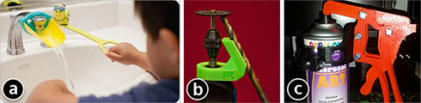

Figure 4.2: Existing examples of adapting everyday objects: a faucet extension (a), a guide for sharpening drill bit (b), and turning a spray-can to a spray-gun (c).

range of likely useful adaptations. However, it can also be seen as an early exemplar in a class of design tools which can make 3D printing more accessible and useful for ordinary people. In particular, it goes beyond the specification of geometry alone to provide very application domain specific knowledge and features. This helps to substantially reduce the gulf of execution [41] that users must bridge as they cross from function to geometry, e.g., from geometric form to the implications of that geometry on the desired end result.

## Scenario Walkthrough: Adapting a Cutter

Reprise lets a user explore a range of design strategies for adapting everyday objects. To set the scene, we first walk through the flow of Reprise in an exemplar scenario where Larry–an occupational therapist–is trying to adapt a wire cutter for an electrician who recently suffered from a hand injury.

### Iteration I: Generating Wrappers for a Better Grip

To start, Larry imports a 3D model of the cutter (from a provided repository or through scanning). He selects ‘Grasp/Hold’ as the type of action the patient is having difficulty with. He then clicks on the handle of the cutter to specify the part that is being grasped. Reprise shows a virtual hand model, which Larry can rotate to indicate the relative orientation between the gripping hand and cutter (Figure 4.1b). Next, Larry selects ‘Wrapper/Extension’ as the adaptation strategy. Based on the previously specified grasping action and its hand orientation, the system generates an initial design of the wrapper (Figure 4.1c). Larry wants to further tweak the design using simple slider controls. He adjusts the ‘Length’ slider to make sure the wrapper covers an area large enough for three fingers. He then increases the thickness to make a rounder grip. To further tighten the grip, he adds small bumps to increase the friction (Figure 4.1d). Finally, Larry exports the generated geometry as an STL file and prints the adaptation using a soft material (such as NinjaFlex4), which provides a soft grip and makes the wrapper snugly fit with the cutter’s handle (Figure 4.1e).

4<http://www.ninjaflex3d.com/products/ninjaflex-filaments/>

### Iteration II: Making Levers to Assist with Clutching

Larry’s patient responds positively to the soft wrapper. However, while he can now comfortably hold the cutter, his hand is still too weak to perform the necessary clutching action, especially when cutting hard wires. Thus Larry explores an alternate design strategy. In Reprise, he first selects ‘Clutch/Squeeze’ as the target operation. He selects the two handles as the components on which clutching is applied, and then moves the cursor to indicate the fulcrum of clutching. In these few steps, he specifies the two arms for clutching (Figure 4.1f). With this information, Larry proceeds to select ‘Lever’ as the adaptation strategy, which automatically generates two levers from the handles (Figure 4.1g). Larry then tweaks the design, playing with the torque of the levers, as well their size for grasping.

### Iteration III: Anchoring the Cutter for Situated Use

Larry’s patient does not like the lever design, as it makes the cutter somewhat too big to hold in one hand (Figure 4.1h). To solve the problem, Larry uses Reprise to replace one lever with an anchoring structure with which he can affix one of the cutter’s handles on the work surface (Fig- ure 4.1ij). The patient then simply uses his palm and body weight to press down and cut wires. The key here is to firmly attach the anchor to the cutter’s handle. Reprise’s attachment toolkit allows Larry to generate a pipe clamp for holding the cutter in place on the anchor (Figure 4.1k). Once printed, Larry bolts the cutter on the anchor, which is then clamped onto the patient’s work surface (Figure 4.1m).

To summarize, Reprise allows Larry to generate adaptations with just a few clicks, to tweak the design using simple slider controls, and to explore different design strategies while iterating and customizing the adaptation to suit the patient’s particular needs and preferences. Below we describe a design space that informs the design and implementation of Reprise.

## A Design Space of Adaptation Strategies

For years, well before digital fabrication was widespread, people have been taking a ‘bricolage’ approach for making adaptations on objects that would otherwise be difficult to use. In particular, many innovative solutions came from the need to create assistive technologies (AT) for people with special needs. For example, Werner documented his effort in making assistive technology for village children with very limited resources [80]. Books like [46,](#_bookmark193) [64,](#_bookmark211) [87] have compiled simple recipes for individuals to adapt household items and tools with materials that can easily be found at home. Although started with a small and specific audience, these AT design and making solutions usually have a broader impact and implication on universal design [17].

Another source of inspiration is online communities such as Thingiverse [70] and Pinterest [44], which curate a repertoire of lifehacking solutions people have explored and shared with one another. Recent work by Buehler et al. [9] has summarized a plethora of assistive technology from Thingiverse, which suggests promising opportunities of learning from these resources.

To inform the computational design of adaptation, we collected and reviewed over 3000 lifehacking and assistive technology examples from the aforementioned literature (85 from [46],

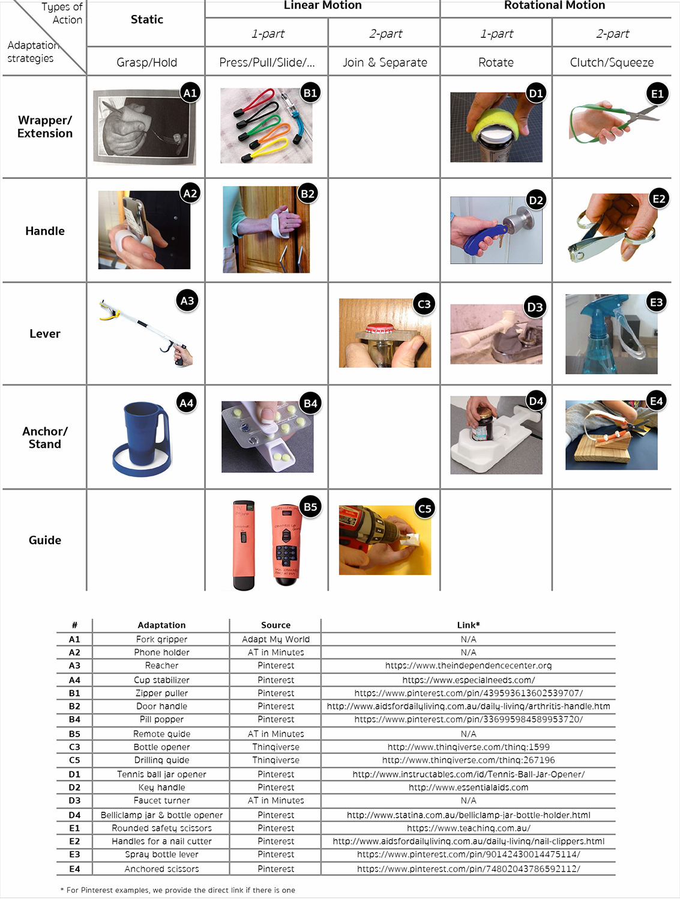

Figure 4.3: A design space of adaptations summarized from over 3000 existing examples: five major adaptation strategies support various types of actions, from static grasp and hold, to linear and rotational motion that involves one or multiple parts of the objects.

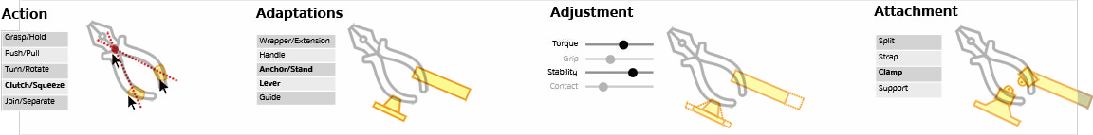

Figure 4.4: The design workflow of Reprise. Start with specifying the types of *action* applied on an object, which serves as input for generating user-selected *adaptations*. The initial design can be further customized by *adjusting* a set of parameters. Finally, extra fasteners can be added to make adaptations more *attachable* onto the object.

56 from [87], and 33 from [51]) and online communities (950 from Pinterest and 2028 from Thingiverse using queries ‘assistive’, ‘technology’ and ‘adaptation’). Amongst these examples, we identified adaptation designs, and organized them into themes in a bottom-up fashion. This sampling process continued until we felt that we had reached saturation.

We present our findings as a design space of adaptation strategies. As shown in Figure 4.3, we identified five major categories of adaptation designs, as well as the types of actions they support to hold, control or operate the objects. While some examples might fit in multiple categories, this design space captures the range of ideas we found in our review and suggests opportunities for novel adaptations (which we discuss in the Results section).

**#1 Wrapper/Extension** is something wrapped around an existing object or an extension that lengthens or expands it. Wrapper and extension support various actions with objects. A wrapper can be used to soften the grip (A1), or to assist with grabbing and rotating an object with less force or less fine motor control (D1). An extension can help with pulling an object (B1) or–with a specific design–to enhance safety for cutting tools (E1).

**#2 Handle** is an add-on grippable part attached to an existing object, which makes the object easier to hold (A2), pull (B2), or rotate (D2). Adding handles also helps with clutching, such as using a nail cutter (E2).

**#3 Lever** is a structure added to an existing object, usually to make it easier to be turned or rotated, such as the lever used in D3 for turning a faucet, or in E3 for squeezing a spray bottle. In other cases, a lever also affords actions other than rotation, such as grabbing objects (A3), or opening a beer bottle (C3).

**#4 Anchor/Stand** is a structure with which an existing object can be stably situated or affixed to the environment. Figure 4.3 shows a stand to hold the cup stable (A4), a pill popper for holding a pack of pills and popping them out (B4), a clamp for holding a jar or bottle for easier opening (D4), and an anchor for a pair of scissors for situated use (E4).

**#5 Guide** is a structure that guides the movement of, or against, certain objects or their components. B5 shows a guide for locating and pressing buttons on remote controls. C5 is a guide for drilling a screw vertically towards and into a surface.

Having summarized these five major adaptation strategies, below we describe the technical details of Reprise–a tool that integrates and implements these strategies for generating 3D print- able adaptations.

## Reprise: Computational Design of Adaptations

Figure 4.4 shows the workflow of Reprise. Users start with importing a 3D model of an object they want to adapt, specify what types of action is applied, and on which parts of the object. Next they select an adaptation strategy from a library provided by Reprise, which automatically gen- erates the geometry. This initial design can then be customized by adjusting a set of parameters. Finally, extra fasteners can be added to better attach the adaptations onto the object. Reprise then exports all the generated geometry as 3D printable STL files.

### Techniques for Specifying Types of Action with an Object

As a user selects a type of action, Reprise provides interaction techniques for specifying where and how the action is applied on the object. As 3D geometry itself does not encode how an object is used in the real world, Reprise’s techniques enable the users to specify this information *in situ*, which later serves as input parameters for generating adaptations. Most of these techniques–as described below–start with the user selecting one ore more *points of action*–the locations on the object where it will be held, controlled, or manipulated.

**Grasp/Hold** As shown in Figure 4.5, Reprise displays a virtual hand, which can be rotated by moving the mouse cursor around the point of action. This allows users to describe the relative orientation between the grasping hand and the object, such as forming a cylindrical grasp [15] on a fork (Figure 4.5a), or a spherical grasp [15] on the cap of a water bottle (Figure 4.5b). Reprise also provides a simple jig (Figure 4.16) for measuring the target user’s hand size, which can then be entered into the system.

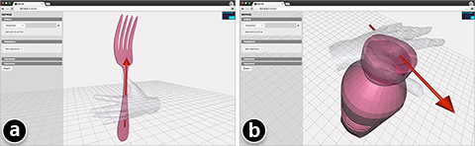

Figure 4.5: Reprise shows a virtual hand to let the user specify how an object is grasped, such as forming a cylindrical grasp on a knife (a), or a spherical grasp on a bottle (b).

**Push/Pull** A spherical control is used to let the user specify the direction of the push/pull, such as pressing a small power button on a remote (Figure 4.6a), or pulling a zipper pull hori- zontally (Figure 4.6b).

**Rotate** The user selects the plane (*XY* , *Y Z* or *ZX*) on which the object is rotated, such as the vertical plane on which to turn a door handle (Figure 4.7b). Next the user selects the fulcrum (Figure 4.7c) within that plane. Reprise dynamically displays an arrow pointing from the fulcrum to the point of action to help the user specify the rotating arm (shown as the arrow).

43

Figure 4.6: Reprise uses a spherical control for specifying pushing/pulling an object, such as pressing a button on a remote control (a), or pulling a zipper (b)

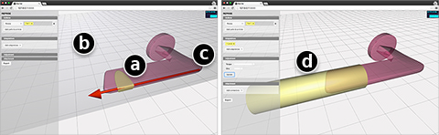

Figure 4.7: To specify rotating an object, Reprise lets a user select where the object is held (a), on which plane it is rotated (b), and the fulcrum of rotation (c). The red arrow shows the rotation arm along which a lever can be generated (d).

**Clutch** usually involves two components, such as clutching the two handles of a cutter. Thus the user will select two points of action on the object, such as the handle and the neck of a spray bottle. The plane of clutching is then computed from the normals of the selected points as well as the line segment formed between them. Similar to Rotate, the user then selects a fulcrum on that plane where two arrows are shown indicating the directions of the clutching arms ((Figure 4.8a). **Join/Separate** involves two objects moving towards or away from each other. To simplify the problem, Reprise uses their bounding boxes to describe how the objects will be joined or separated. Specifically, the user will select two faces, respectively, from the two bounding boxes, which then shows the direction along which the two objects will moved towards or away from one another. For example, as shown in Figure 4.9a, the key would go into the lock hole along its

teeth as indicated by the arrows.

### Computationally Generating Adaptations

Taking the user-specified actions as input parameters, Reprise then provides a list of strategies for rapidly generating the initial design of adaptations. The specific methods for generating these models are based on the aforementioned survey of existing adaptation examples (Figure 4.3). In generating these adaptations, Reprise uses variations of a cylindrical geometry as the primary

44

Figure 4.8: To specify clutching, the user selects the two parts of the object that are being clutched and then the fulcrum. The red arrows indicate the directions of the clutching arms (a). The user can generate a lever for clutching the spray bottle, while holding its body in hand (b).

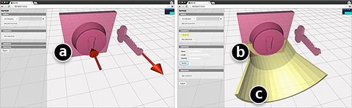

Figure 4.9: Reprise lets the user specify moving one object towards or away from another, such as putting a key into a lock hole.

building blocks, and a series of Constructive Solid Geometry (CSG) operations for creating the specific adaptations.

For example, a cylinder wrapping around part of an object can make a wrapper (Figure 4.10a) or a lever (Figure 4.7b and Figure 4.8b). Extruding a cylindrical structure from an object’s surface creates an extension, such as enlarging a button on a remote control (Figure 4.10b). To make an anchor, Reprise creates a cylindrical pillar that connects to a rectangular base at the bottom, and to the object at the top (Figure 4.13a). When creating a guide, it is also possible to use an object’s bounding cylinder to represent its path of movement, which creates a ‘tunnel’ (Figure 4.9b) with a wide ‘opening’ at the entrance (Figure 4.9c). By default Reprise displays the models in 1:1 scale to let the user get a concrete sense of the adaptations’ size and dimensions when adjusting these parameters.

### Adjusting Design Parameters for Customization

With the initial design of the adaptations, Reprise provides users with simple slider controls to adjust the design parameters for further customization. For example, for gripping, they can lengthen a wrapper so that it can be held by multiple fingers (the sizes of which can be measured

using a tool described later in Figure 4.16); they can also adjust the radii of the cylindrical components, or add small bumps on the surface to tighten the grip (Figure 4.10a). To enhance strength and support, they can increase the torque of the levers, or give the anchor or stand a larger base. For easier hand coordination, they can widen the opening in a guide, making it easier to move one object into the ‘tunnel’ and towards the other object (Figure 4.9c). To adjust the overall size, they can make a handle more elliptic or vary the length of its arc (Figure 4.11c). To help users navigate the rich parameter space, Reprise also allows them, with one click, to generate a large set of design variations (Figure 4.11a*→*b), similar to the technique in Side Views [68]. This provides them with a more intuitive way of browsing and comparing different designs, select one that best matches what they have in mind (Figure 4.11b*→*c), and from which they can continue to customize the model (Figure 4.11c). For example, as shown in Figure 4.11, to make an adaptation for grasping a fork, the user can select wrappers of different length, thickness, and

tightness, as well as handles of different sizes and styles.

### Attaching Adaptations onto Real World Objects

As a last step, the user normally wants to generate some attaching mechanism(s) for installing the adaptations onto the object. Prior work, such as Encore [11] and AutoConnect [30], has explored a range of attachment techniques, which can be used as a post-processing step to install the adaptations.

In addition, Reprise also offers several simple built-in techniques for making the adaptation more attachable. For example, ‘Split’ lets the user draw a stroke on the model of the adaptation (Figure 4.12a) to split it into halves (Figure 4.12b), such as splitting a wrapper so that a fork can be placed in it (Figure 4.17a). ‘Clamp’ lets users create a simple pipe clamp: first position- ing the pipe (Figure 4.13b) and then stroking a line to cut the pipe open and generate clamps (Figure 4.13cd) where a bolt can be used to fasten the structure. ‘Beams’ can be added to the adaptation by selecting a point on the object and another point on the adaptation (Figure 4.14ab). This will generate structures to further support the object, such as to further stabilize a mug (Figure 4.14c).

In some cases, part of an object is not accessible or should not be occluded by the adap-

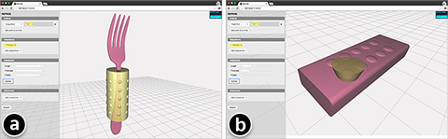

Figure 4.10: Reprise can generate a wrapper–a cylindrical structure bounding part of an object (a), or an extension–an extrusion from a selected area of the object (b).

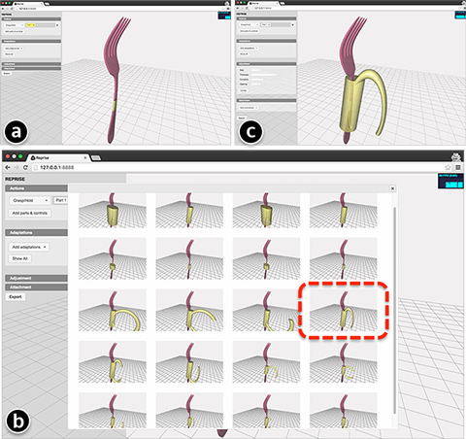

Figure 4.11: Besides using sliders, users can also click a button to generate a large set of design variations (ab), from which they can select one that best matches the design they have in mind, and continue to develop it from that model (c).

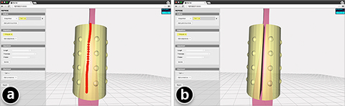

Figure 4.12: Reprise provides a simple technique to split an adaptation in halves so an object, such as this fork, can be put inside a wrapper (Figure 4.17a).

tations, such as a phone’s screen. Reprise allows a user to specify which part of the object should be excluded when generating adaptations. As shown in Figure 4.15a, the phone’s screen

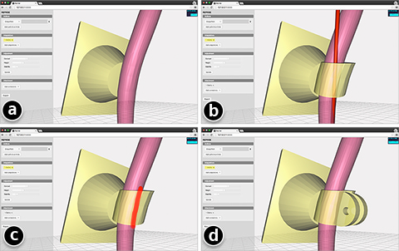

Figure 4.13: A pipe clamp, provided by Reprise, attaches the generated stand (a) to the object. Clicking on the object places the pipe (b). Another stroke cuts it open and adds a pair of clamps (cd).

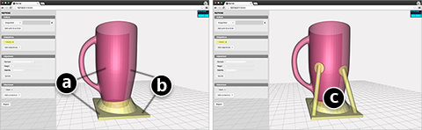

Figure 4.14: Beams can further support the object for an adaptation. To generate one, simply select a point on the object and another point on the adaptation.

is marked as inaccessible (red), and accordingly the generated handle avoids covering the screen area (Figure 4.15b).

### Implementation, Measurement and Fabrication

Reprise was implemented using JavaScript with three.js5 and OpenJSCAD6. The tool can run readily inside a modern browser. Reprise curates a 3D model repository of common household

5<http://threejs.org/>

6<http://openjscad.org/>

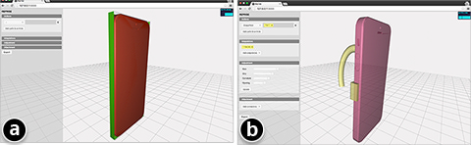

Figure 4.15: As the phone’s screen is marked as inaccessible (red) by an adaptation, the generated handle avoids covering that area.

items and hand tools; alternatively, it also uses Skanect7 and the Makerbot Digitizer 8 for digital- izing objects. The spray bottle in Figure 4.8 was scanned using the Skanect system.

For some adaptations, users might need to measure the hand or finger sizes of the person. Reprise comes with a simple measuring tool (Figure 4.16) that can be printed (and cut) on a piece of paper, or made with a laser cutter. The hand measuring part is based on a method for determining the size for a golf glove9. The finger part is based-on standard ring-size metrics.

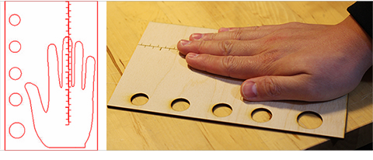

Figure 4.16: Reprise also provides an SVG file for making a measuring tool for adaptations that require fitting users’ hand or fingers. This one shown above was laser cut.

For fabrication, we used material with various softness, ranging from regular PLA, to Semi-

7<http://skanect.occipital.com/>

8<http://store.makerbot.com/digitizer> 9<http://www.jumbomax.com/sizing/>

Flex10, Nylon-based11 or NinjaFlex12. All the results–as we demonstrate below–were fabricated using an inexpensive Printrbot Play 3D printer13.

## Results and Validation Through Replication

Compared to traditional CAD tools where models are mostly created from scratch, Reprise has integrated application domain specific knowledge that allows users to specify, generate and cus- tomize adaptations at a higher level. While there may remain some usability issues with our tool, this application domain targeted approach clearly allows adaptations to be specified much more easily than trying to create them as unstructured arbitrary geometry in a general-purpose tool. However, this ease of use can come at a price, and this raises the important issue of whether the tool can create a wide range of objects to cover an interesting and useful space. To answer this more difficult question, we validate Reprise by focusing on its breadth of expressiveness. In par- ticular, we used it to replicate a wide spread of existing adaptation examples. This demonstrates the potential for Reprise to support the full range of adaptations that are demonstrably useful in the real world.

Specifically, we chose to replicate representative cases from different ‘cells’ in the design space of adaptations (Figure 4.3). Below we showcase our results, discuss issues that arose during the process, and identify cases where Reprise is not yet able to generate the adaptations, which suggest opportunities for future work.

**#1 Wrappers/Extensions** As shown in Figure 4.17, Reprise was able to replicate all the four wrapper/extension examples in the design space. The virtual hand was effective in positioning the wrapper at the right place on the objects. However, in the case of the cutter handle, we found that the simple cylindrical structures did not fully conform to the curvature of the handles (Figure 4.17d). A new feature for future work would be to ‘curve’ the wrapper so that it can better represent the original geometry of the object.

**#2 Handles** All types of handle examples in the design space were replicated using Reprise (Figure 4.18). Reprise allows users to explore different handle designs, such as making a ‘closed loop’ for holding and turning a key (Figure 4.18c), or half-open for easier placement of the hand when holding a phone (Figure 4.18a) or pulling open a cabinet door (Figure 4.18b).

A single handle can be used to stabilize the grip of a pen (Figure 4.22a) while it is also possible to combine multiple handles to match different fingers (Figure 4.18d). In particular, for fingers, initially we found it really hard to specify a fixed spatial relationship between them and the handles, as their position and orientation could vary from time to time while holding an object. Later we found that using soft material could mitigate this problem, as its deformable nature offers a range of adjustable configurations. Although Reprise operates at the geometry level, it is possible, as a future step, to fine tune the geometry of a handle as a way to ‘program’ its range of configuration when printed with soft material.

10<http://www.ninjaflex3d.com/products/semiflex/> 11<http://www.graphene3dlab.com/>

12<http://www.ninjaflex3d.com/products/ninjaflex-filaments/> 13<https://printrbot.com/shop/assembled-printrbot-play/>

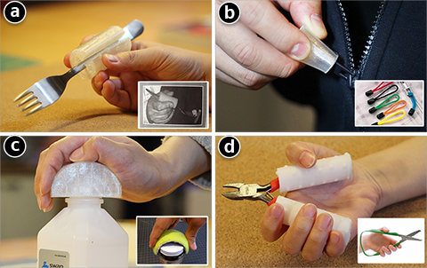

Figure 4.17: Replicated wrapper/extension examples. Ninjaflex was used for the fork wrapper (a), zipper handle extension (b), and the bottle lid wrapper (c). Nylon-based soft material was used for the cutter.

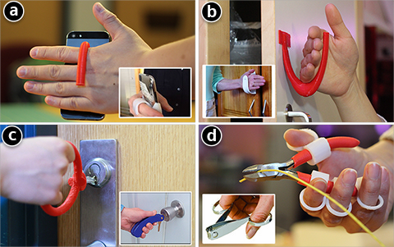

Figure 4.18: Replicated handle examples.

**#3 Levers** Figure 4.19 shows Reprise’ replication of levers. One current limitation we found is that Reprise can only generate levers where part of the existing object has a degree of freedom to be rotated or squeezed. In the future we plan to explore other use cases of a lever, such as for clamping (Figure 4.3-A3) or separating (Figure 4.3-C3) static objects.

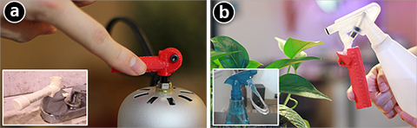

Figure 4.19: Replicated lever examples.

**#4 Anchors/Stands** Besides the aforementioned cutter, we also replicated two other an- chor/stand examples as shown in Figure 4.20. When making these examples, we often found it necessary to add extra fasteners or support structures, such as the pipe clamp for the cutter (Figure 4.20a) and the supporting beams for the mug and the sharpie anchor (Figure 4.20bc). Rather than adding them as a follow-up step, future work could integrate these components para- metrically as part of the generated adaptation.

**#5 Guides** Inspired by the drilling guide example (Figure 4.3-C5), we used Reprise to gen- erate similar structures for guiding a key towards a lock (Figure 4.21a) and putting a sharpie back into its cap (Figure 4.21b). We did not replicate the remote control example as it stands (Figure 4.3-B5), as it seems simple enough to be made with paper, and further it sacrificially occludes other buttons. Instead, we opted for an alternate design–an extension on the button that makes it a larger target for pressing (Figure 4.10b). It is interesting to see that in this case an extension can also serve as a guide, which suggests the possibility of ‘remixing’ categorically different adaptation strategies.

One limitation we found is that Reprise currently only guides linear motion; in the future it should be possible to explore how to generate guides for other types of motion, such as a guide for turning faucets to get (only) mildly warm water.

## Discussion and Summary of Designing Adaptations

Based on our exploration of the design space, tool integration and fabricated results of adapta- tions, we now discuss existing issues, limitations and potential future work.

**Combining different adaptations** With Reprise, it is also possible to combine different adaptation strategies. Figure 4.22 shows a series of sharpie adaptations generated by Reprise, ranging from a handle for holding (Figure 4.22a), the aforementioned guide (Figure 4.22b) and anchor (Figure 4.22c), and finally, a combination of the three (Figure 4.22d). Our current ap- proach is to incrementally add new adaptation with the previous ones considered as part of the object. However, the ordering of addition could cause adaptations to conflict with one another. For example, adding a handle might make the sharpie no longer fit in the guide installed ear- lier. Future work could optimize the order of adding multiple adaptations to reduce conflict, or updating existing adaptations as new ones are added.

52

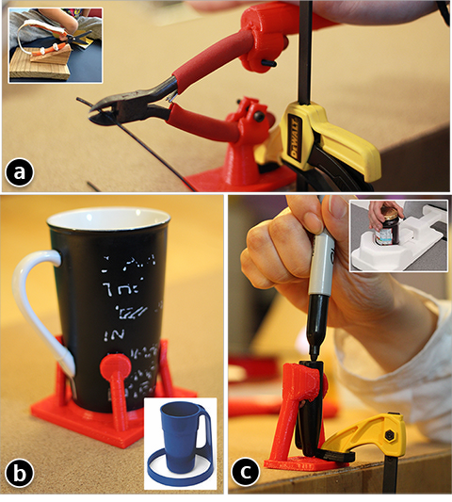

Figure 4.20: Replicated anchor/stand examples.

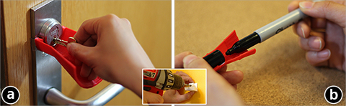

Figure 4.21: Replicated guide examples.

**Expanding the feedback loop for customization** Rather than just taking the original object as input, future work could enable a more iterative approach where a printed piece of adaptation can be fed into the system to let the user further customize it. Prior work, such as ModelCraft [62] could potentially be extended here to let the user annotate printed results for the next design

53

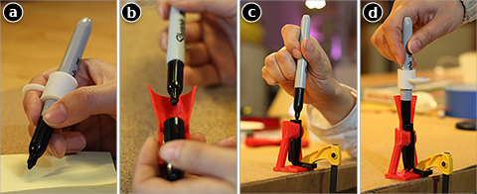

Figure 4.22: Combining multiple adaptations: a handle (a), a guide (b) and an anchor (c) can be combined into one (super) adaptation (d).

iteration.

**Scaling up reprise to adapt larger objects** Most of the objects Reprise adapted so far are hand-sized items or tools. In future it would be interesting to explore larger scaled adaptations, such as making a bath tub safer to walk in/out, or making room entrances or stairwells more ac- cessible. The challenges are two-fold: how to scale up the current design workflow to incorporate large objects, and how to go beyond the usual volume of 3D printers to fabricate the adaptations.

**Combining hand-making and digital fabrication** Although we designed Reprise for 3D printing, we believe it may work best as a tool that complements existing hand-making ap- proachs, rather than replacing them. Hand-making can capture users’ intuition and creativity (even though the outcome is still limited by the materials available and the users’ making skill). Future work could transform Reprise’s workflow to incorporate or augment handmade proto- types, such as using 3D printed fasteners to connect handmade parts, or to serve as components that require higher functional precision.

**Using vision-based sensors to capture object usage** As we designed the virtual hand for specifying different ways of grasping, we realized the possibility of an alternate approach where the person can use an RGB+depth camera (e.g., Kinect) to show their grip by performing it. This seems a more natural way to express one’s difficulty with objects. Further, the person’s hand shape might also be captured by first gripping a piece of clay [8] and then digitalizing it. Although compelling, this type of vision-based approach has inherent issues, such as the imprecision of the sensors and the general difficulty in reconstructing the captured data into high-fidelity 3D models.

In my work thus far, either extending or adapting existing objects allows for incremental ‘delta’ for transforming the real world, as their functionality is somewhat dependent on the ob- jects they are attached to. For a non-incremental approach, where brand-new objects are created from scratch, the objects we create will often end up physically interacting with others. A book-

shelf will be used to put on books. A chair will be sit on. A step stool will stood upon. How can facilitate the design process so that objects like these can function properly and reliably with real world objects they will be used with. My next chapter proposes a design tool to support users in conducting such fuctionally aware design tasks.

**Chapter 5**

**Mixed-Initiative Design for Real World Functional Requirements**

To tackle the grand challenge of transforming the physical world, my next step would go be- yond making add-on augmentations or adaptations, but rather focus on designing and fabricating larger-scale objects that also have to address various functional requirements of the real world.

In both of the previous projects—Encore and Reprise, the design task is based on an existing object and the outcome is some sort of extension that enhances a specific function of that object. While this approach works for creating something incremental (e.g., adaptation), it becomes problematic when scaling up—creating self-contained objects such as bookshelf, step stool, or wine rack.

There are several challenges in designing this class of objects. Foremost, as they are no longer incremental add-ons to existing objects, it would be difficult to create a design *in situ* from these real world objects. Consider making a bookshelf for example. It is less straightforward if one has to start the design with some books; rather, a more intuitive approach is the reverse: create the bookshelf first, then see if it has enough space, or is strong enough to accommodate the books. However, for non-expert users, it is hard to create a functional design by intuition. A user might have an intuition about what their bookshelf should look like, and might be able to sketch the design; but they would probably have trouble making sure that this design would work—that is, supporting all the books to be put on it.

To ensure that a design meets its functional requirement, one popular approach is to employ topology optimization [4]—a well-established practice in mechanical and civil engineering. Es- sentially, topology optimization ‘automates’ the design process by reducing the design input to only the functional requirements, e.g., overall size, amount of material, weight of loads, how the object is affixed to the world. The method then attempts to generate the strongest possible design given all these parameters as constraints. Although it gives functional assurance, from an HCI standpoint, topology optimization is too much of a ‘black box’ that gives users very little control of expressing or editing their own design.

In my ongoing work, I want to combine the best parts of both worlds: enabling users to sketch functional objects of their design by bootstrapping the process with topology optimiza- tion to transform the design into a functional one. Meanwhile, users will also receive step-by-step feedback and suggestion that connects the two worlds: as they create or edit their work, visu-

alization informs them how the functionality is changing and what are the options to tweak the current design while staying with constraints. This mixed-initiative approach allows the system to assist users with their design task without limiting their freedom of creating or editing the ob- ject. As a result, users can benefit from delegating the functional aspects of design to the system while focusing on the visual appearance and styles. I hope such a design environment can help people fabricate a variety of things that meet real world requirements without requiring too much expertise from the user.

There are several expected challenges in realizing this mixed-initiative approach, which are discussed in depth by Horvitz [23]. Foremost, there are many possible ways for a tool to combine user and system initiative. How much control shall the tool keep for the user and give away to the system? How can the user communicate their intent to the system and the system communicate its intelligence to the user? How can the system ‘merge’ the two ends, resolve potential conflicts and finally achieve a result better than what the user (or the system) alone can achieve?

**XAC: moved original review to Ch2; added a few more optimization-specific works, which are more appropriate in this context** As reviewed in Chapter 2, prior work has explored guided design to help users achieve functional validity while designing geometry of objects. Specifically related to topology optimization, Christiansen et al. develop a tool to fully automate the design process from specifying input parameters (loads, boundary, objective, etc., which is detailed later in the chapter) to generating a functionally valid result that can then be fab- ricated [14]. However, it is somewhat unintuitive to start a design with functional consideration, rather than allowing users to describe their desired model to the system. Another challenging aspect of performing optimization is the scalability of performance. The demand for high res- olution of the design will inevitably post challenges on interactive tools. Wu et al. developed a scalable system using high-performance GPU-based solver to execute topology optimization, allowing million-scaled resolution [88]. Although we can always expect future engineering ef- fort to overcome today’s performance issues, the development of design tools still need to keep in mind these potential performance challenges and constraints.

Building upon all this prior work, my research goal is to develop an end-to-end design tool with the following mixed-initiative work flow:

* + - Enabling user to start with sketching or modeling a design from their intuition, without necessarily addressing any functional issues
    - Next, guiding the user to go beyond the initial design and describe real world functional requirements, including

how is the designed object situated in the real world?

what is its spatial relationship with people and other real world objects?

* + - Then users can iterate on the design back and forth between editing on their own and ‘handing over’ the task to the system. Specifically, the user can edit their design based on a graph representation, while the system

visualizes the ‘weak spots’ - the stress of the design as a heat map rendered on the designed object

computes an topologically optimized result given the functional constraints and the current design, which is then overlaid with the user’s work as a way to inform them

of potential changes to make to achieve a stronger structure.

based on mechanical domain knowldege, provides a set of reinforcement solutions whereby users can select and apply to improve the current design

* + - As the user becomes satisfied with the result, the system converts it into ‘fabricatable formats’ that consists of 3D models of components and connectors to be assembled for the actual object.

As the work is still in progress, in this proposal I briefly describe several key components I envision of this project.

## Sketching an Initial Design

Sketching is perhaps the most intuitive way of describing one’s idea of a design, even for 3D objects. Igarashi et al. develop Teddy—a sketching interface whereby users, with a few 2D strokes, can create free form 3D models [27]. Saul et al. applied a similar idea to designing chair: first drawing the 2D profile of the chair then ‘extruding’ it for a complete 3D model [53]. Through making a ‘rough’ sketch to start a design, users are able to follow their intuition and creativity, rather than worrying about the detail or trying to overcome the general difficulty of creating 3D models.

Thus the start-up interface of Mashup is no different than a familiar 2D sketch pad where users can create any freeform drawing representing an object they wish to design and fabricate.

Next, Mashup converts the drawing into a graph representation that is amenable to further editing, enhancement, and the eventual requirement of fabrication. Essentially each drawn stroke becomes an *edge*, and incident edges are automatically joined by a *node*. At this stage, each edge is essentially a polygonal chain (or more commonly known as ‘polyline’); further iteration can add thickness along the edges and the nodes that connect them.

Such a representaiton is amenable to fabrication. Each edge will be fabricated as a mechanical component, such as a metal wire or a plank of wood; each node requires the need of a connector that can accommodate all its edges; the thickness of the edges and nodes specifies the scale of these components and connectors.

Such a representation is also amenable to editing: once a sketch is created and converted to this representation, users can edit it by dragging and repositioning the nodes, removing nodes or edges, splitting an edge, or changing the thickness along an edge.

Finally, both the sketch and the subsequent representation are extensible to 3D. Users can tilt the 2D canvas and sketch ‘out of the paper’. However, at any given time, users only need to deal with 2D sketching or editing, which is mapped to a 2D canvas automatically computed based on the users’ viewing angle (i.e., the camera angle of the 3D scene). Alternatively, users can also ‘extrude’ a 2D sketch along a third dimension to make it a 3D model, which is similar to the SketchChair’s approach [53].

## Specifying Functional Requirements

To design a functional object, a visual sketch is not enough to describe its functional requirement. As a next step, Mashup guides the users to transition from thinking of the design visually to considering and describing its functional aspects. One important functional aspect for many everyday objects is the ability to sustain themselves as well as other objects interacted with. Furniture is a class of such objects: step stools, chairs, tables, bookshelves, and clothes racks are just a few examples of objects that need to sustain things to be put on them or people to be sitting, standing or lying on them. Other examples include all kinds of bases, stands, holders, hooks, all of which are also required to support certain objects when deployed to use.

**Loads** Mashup lets users specify these functional requirements in just a few steps. Specifi- cally, as users finish the initial sketch, they can switch to the ‘functional specification’ mode, in which they can click or tap on their drawing to specify where other objects or people might be situated, such as where books are placed on a bookshelf, where people stand on a step stool, and clothes are hung on a rack. This is called a *loading point*. Next, Mashup infers the direction of the force exerted by the load, which can be computed by taking the normal of the sketch at the loading point. Users can then estimate the amount of load by adjusting a slider.

**Margin** Further, to inform future iteration, some space on the original design needs to be allocated and kept empty so loads can be put in place, such as leaving enough space on a shelf to put on books of certain size, or clearing space above a step stool for people to step on. Such necessary empty space is called **margin**. As shown later, marking margins prevents the system to mistakenly add extra components to the original design that might defeat users’ original intent of usage. Margin can be specified immediately following a load: users can extend the loading point to a bounding box delineating the space of margin.

**Boundary** Besides loads, another important piece of functional information has to do with how an object will be situated in the real world once fabricated. In many cases, objects will be placed on the ground or some horizontal surfaces, such as chairs, bookshelf, tables. Others might have different scenarios, such as a hook attached to the wall, a candle chandelier hung from the ceiling. These points of affixation are called *boundary*. At points of boundary, forces will occur to counteract those exerted by the loads, such as the ground would support a chair while a person puts their weight on it. Users can specify a boundary by first selecting a point on the sketched design, and then expand it as a bounding box to encompass the size of bounary.

At this step users have to go beyond the initial design and think more about the functional aspects of the object. Mashup seeks to make such functioal specification simplied to only a few steps, and closely associated with and based on the original sketch rather than having to describe it in purely abstract and technical terms.

## Iterating a Design with System Feedback and Suggestion

Although at this point users have provided functional requirements of the object in design, mak- ing sure that the design satisfies these requirements would still demand expertise that might go beyond everyday users. Thus, as the users iterate on their initial design, Mashup wants to bring in computational support through which the system might take various degree of initiative to

60

help the users enhance the functional aspects of their design. Primarily, Mashup provides users with *feedback* that shows the ‘goodness’ of the current design and highlights problematic parts. Mashup also offer *suggestion* that informs users how they can strengthen the design to better meet the functional requirments.

### Analysis and Feedback

Mashup’s feedback is primarily based on a finite element analysis (FEA) of users’ design and the functional requirements they have specified. In short, FEA discretizes a design into con- nected elements (e.g., voxel grid) and analyzes their behavior given the intrinsic geometry and the external forces (e.g., loads).

One useful metric computed from FEA is the *displacement* of the design’s constituent el- ements. Microscopically, this metric indicates how an element will move given all the design paramters; macroscopically, displacements of elements can jointly reveal how the object in de- sign will react to an actual usage scenario, such as collapsing under weights, or toppling due to imbalance. A global displacement vector *U* (consisting of displacements of all the elements) is governed by the following relationship:

**F** = **KU** (5.1)

*F* is the global force vectors. *K* is the global stiffness matrix, which is dictated by the material property of the object.

Once displacement is computed, Mashup visualizes it as an overlay atop the users’ design. Inistead of overwhelming users with visual details, Mashup converges the displacements of each elements to ‘global arrows’ showing potential movement of entire object under the specified loads.

While displacement shows the result of a design, it does not necessarily indicate the causes of it. For example, if a branch of a clothes rack bends under the weight of clothes, the cause is often not at the tip that displaces the most, but rather at the bottom due a lack of support. Thus Mashup also computes *stress*—a metric that is more indicative of the cause of structural problems. Similar to displacement, stress is also computed in an element-wise manner. At element *e*, assume *v*1, *v*2 and *v*3 are vectors from this element to three of its connected neighbors. Correspondingly, *V*1, *V*2 and *V*3 are vectors after the displacement. First, we compute a transformation matrix *F* that describes the spatial relationship between these two sets of vectors:

*F* [*v*1*, v*2*, v*3] = [*V*1*, V*2*, V*3] (5.2)

With *F* , we can then compute the Green strain:

1

*E* = (*FT F I*) (5.3)

*−*

2

By taking the Frobenius norm of *E* we can obtain a value that indicates the stress of the ele- ment. To visualize this information, Mashup creates a heatmap rendered over the users’ design.

61

### Optimization and Suggestion

Although feedack informs users of problems of their design, it does not provide solutions. As such, Mashup attains to translate the analysis results from the previous step to actionable sug- gestions that will guide users to modify and enhance their design in a problem-solving manner.

The first approach of suggestion is to provide a built-in collection of ad hoc solutions and to apply them to the current instance of design. For example, a rule of thumb for strengthing a weak spot of an object is simply to make it larger in volume. To support a horizontal structure, we can always connect overhanging parts to portions of an object below that structure. Mashup will allow users to choose from these ad hoc solutions, which are then automatically parameterized, generated and attached to the user’s design. Although these small fixes are easy to understand and deploy, they might not effectively solve the design problems—even worse, they might cause new problems while trying to solve an existing one. For example, thickening one part of an object might cause a global imbalance problem. To address this issue, Mashup performs an FEA of the new design in the background as users apply these ad hoc solutions, and visualizes how the solutions are solving problems or causing new ones. Mashup also lets users apply solutions in a ‘suggested editing’ mode, whereby changes are tracked and easily reversible.

In addition to the ad hoc solutions that attempt to fix problems locally, Mashup can also per- forms a global topology optimization, which generates the strongest possible design given all the specified constraints. In short, given a design domain (e.g., the bounding volume of a bookshelf), the functional requirements (loads, margins and boundaries) and the available amount of mate- rial, topology optimization comes up with a structure within the design domain that yields the least compliance (i.e., can best sustain the loads with the least amount of deformation). Through the optimization process, a design is achieved by selectively removing elements from the design domain. Based on the summary by Sigmund [60], the process can be formalized as follows:

*N*

min : *c*(**x**) = **U***T* **KU** = ...(*xe*)*p***u***T* **k***e***u***e,* (5.4)

*x*

subject to

*e*

*e*=1

*V* (**x**)

*f*

*V*0 *≤*

**KU** = **F**

0 *< xmin ≤ xe ≤* 1

As with the FEA for analyzing displacement, **U** is the global displacement vector, **F** is the global force vector, and **K** is the global stiffness matrix. **ue** and **ke** are the displacement and force of element *e*, respectively. **x** is the vector of design variables: for a design discretized into *N* elements, **x** is an *N* -tuple vector with *xe* representing the density of element *e*—the smaller value of density means the more likely this element will be removed; and vice versa. *V* (**x**)*/V*0 *≤ f* describes the constraint on the amount of material.

While this seems a nice ‘shortcut’ to jump from the initial design to a potentially more func- tional one, it has its inherent limitations. Foremost, the optimization process by nature is only

62

concerned with functional requirements. It has no knowledge of what the user would want the final result to look like. Thus as a preprocessing step, Mashup imports user’s initial sketch into the optimization input variables, mark as non-removable elements. Effectively, this stipulates that the final optimization result must contain this initial design. In other words, the outcome of the optimization is additional structure to the user’s original design to make it better fulfill the functional requirements.

However, even with this user input, it might happen that the optimization process will add unwanted components that render the object unusable, such as components on top of a chair’s sitting area. To prevent this from happening, Mashup also imports the previously specified mar- gin to inform the optimization process that there are these elements that must be removed, such as keeping the space above a chair’s seat empty.

### Iterating with User Editing

As the system optimizes user design additively, Mashup allows users to have control of how much extra material will be added. With the aforementioned real time feedback, they can interactively play with this variable to ensure that their design idea is retained while the object remains strong enough to fulfill the functional requirements.

Users can also use their initial design as ‘seed’ to intentionally generate variations—other functionally valid designs that are drawn but also deviate from their original ideas. In the system’s level, this is achieved by controlling the ‘weight’ of user’s initial input—instead of treating these elements as absolutely non-removable, the system can variously loosen the constraint to generate a set of design variations for users to choose from.

Users can also manually edit the object on their own by manipulating the ‘primitives’—the edges and nodes representing the design. They can adjust the length, thickness and position of each component, or add more reinforcement structures, such as a diagonal cross bar to better support a weak spot, or removing ones that no long feeling needed. As they perform such manual editing, they can control how attentive the system is: providing feedback and suggestions step by step, periodically, or on-demand.

## Making a Design Fabricatable

As a final step, Mashup will convert users’ design into something fabricatable. Previously, to simplify the design, users only provide a low-fidelity, skeletal profile of an object. To fabricate the design, Mashup allows the users to produce it as one homogenous object or as separate parts to be assembled.

To make it in one piece, Mashup joins all the ‘primitives’ and generate a cross-sectional area with smoothened profile based on the thickness of the nodes and edges. Users can then simply extrude this 2D profile into a full 3D object. Mashup can either export the object as a 3D printable model, or as other formats, such as for using laser cutting or CNC milling. CNC can accommodate large creation, and requires Mashup to provide the size of the raw wood material and the number of cuts (as each cut has limited dimension along the z-axis).

To using parts and assemble the object, users specify the raw components, such as Lego bricks, planks of wood or PVC pipes. Mashup then computes and generates a corresponding subset of these components, as well as instructions to put together to assemble the design. In some cases, Mashup also generates connectors for joining these components in specific ways (e.g., with specific angle and sufficient strength). When needed, Mashup also generates instruc- tions for cutting the components if their original dimension exceeds what is required to compose the object.

## Summary of Mixed-Initiative, Functionally-Aware Design

Different form Reprise’s tasks of making adaptations attached to existing objects, Mashup attains to produce standalone designs with functional relationship with real world objects. Specifically, it focuses on combining the requirement of sustaining loads of these objects and the freedom for users to express their own design. This mixed-initiative approach brings everyday users further into the realm of functional fabrication without demanding much of expertise from them. In so doing, I hope we can expand the range of things everyday users can make. Next chapter will discuss the possibilities of further involving the users into the fabrication process, by supporting them to carry out the making tasks on their own.

**Chapter 6**

**Supporting Hands-on Design and Fabrication in Real World Context**

My work starts from addressing how fabrication can be done closely integrated and attached to existing objects (Chapter 3), which then suggests a class of adaptation design where extra components can be made to enhance or modify functionalities of existing objects for custom usage (Chapter 4). Whether it is something add-on or standalone, functionality decides the form of objects; however, it can also be combined with people’s intuitive creation through a mixed- initiative approach (Chapter 5). Ultimately, my goal is involve real people not just in the digital design process, but also in the physical making of objects that can functionally fulfill real world use cases. In this chapter, my focus is to explore ways that can support and engage people in performing hands-on design and fabrication directly in the real world context of the objects they want to create.

As mentioned in the earlier chapters, there is a lack of people’s involvement in the actual making process, preventing them from participating in the realization of their design in a closer feedback loop. With a hands-on approach, not only can people get better control of the making process, they can also develop their manual dexterity and, when successfully making something, get to experience the joy of it.

However, hands-on making—in its traditional sense—is not meant for everyone. Foremost, people’s manual dexterity is different, which inherently adds various difficulty to the making process—making ceramics on a turntable is a familiar scenario wherein one’s dexterity is often challenged. Further, even for dexterous people, without some sort of training it might also be difficult to perform making tasks, such as wood working. However, even for trained and experi- enced makers, to execute a making task would still from time to time require some external help, such as the need to refer to the design blue print or assembly instructions. Variance in dexterity, lack of skills and knowledge, and availability of information seem to be the major factors that would prevent or discourage people from getting themselves involved into the actual fabrication process.

Fortunately, the recent advances in Augmented Reality (AR) suggest opportunities of intro- ducing them into the fabrication process. Specifically, wearable AR (e.g., Microsoft HoloLens1)

1<https://www.microsoft.com/microsoft-hololens/en-us>

can superimpose relevant information onto the physical environment, which can readily guide or inform people of their tasks at hand, rather than having to interrupt the tasks and attend to a separate device.

Such capability provides a basic solution for overcoming the aforementioned difficulties of involving people into the making process. As AR is not really a new technology, nor is this idea. Prior work has explored using AR to facilitate collocated, collaborative design, such as Reki- moto’s Transivision system [50]. To support the actual making process, researchers from Boeing built a heads-up see-through display to assist aircraft manufacturing tasks, thus eliminating the need of templates, formboard diagrams and other masking devices [10]. Similarly, Yuan et al. superimposed a virtual interaction panel during assembly tasks for retrieving instructions [90]. Researchers in HCI also performed a comparative study on the effectiveness between AR and traditional printed and externally displayed instructions [66]. They found that using AR greatly reduced errors in assembly tasks and also resulted in less mental demand for the workers. All this prior work almost exclusively focuses on AR-assisted assembly, in which the users’ tasks are pre-defined with a limited scope.

In this proposed project, I attain to explore a full range of possibilities for AR to support an end-to-end design-fabrication task for everyday users. My specific goals are as follows:

* Seamlessly integrating the previously separated design phase and fabrication phase: for people, what they design is what they make, and what they make is what they design.
* Providing virtual references, instructions, feedbacks and suggestions (based on Chapter 5) to help people accomplish physical making tasks
* Digitalizing physical artifacts to enable a descriptive approach of ‘modeling by example’; leveraging the physical environment to help people organize their virtual design space.
* Enabling multi-modal interaction—combining gaze, gesture, motion and voice input to allow users to access and manipulate digital information while being able to focus on the main physical making task.
* Providing an environment that can support a wide range of making tasks, from paper craft- ing, to freeform sculpting, to assembly and installation.

The deliverable of this project would be an integral design environment based an AR-enabled headset, that provides a number of value-added features to a range of making tasks. My hope is with an addition of such a system, people will do a better job getting their hands ‘dirty’, and more importantly, become more willing and encouraged to participate in the making process.

**Chapter 7**

**Discussion and Conclusion**

In exploring my thesis research, many existing issues, limitations, new ideas have emerged, which I discuss in this chapter as reflection on my work to date, as well as envisioning future research.

## Design for Real Use, with Real Objects, by Real People

One important motivation of my research is how we are resuscitating our ability to create things and bring our ideas to physical reality. My work begins with considering not just fabricating objects from scratch, but also to consider their relationship with real world objects, starting with making attachments to them. Then I continue to think about function—creating functional attachments as adaptations or sketching functional objects, both of which address real use cases customizable by users.

However, in my work thus far, users only seem to have control over the digital process of fabrication, such as creating and editing a digital 3D model for fabrication; in contrast, they become much less involved in the actual fabrication process, which is still predominantly taken care of by the machines. Always thinking in terms of what machines can make inevitably limits users’ imagination. For example, quickly browsing through online community like Thingiverse, one would find that most of the 3D printed objects are somewhat small, due to the limited print volume of most consumer-grade printers. Users’ imagination of making larger scale objects seems somewhat suppressed by the awareness of the printer’s limitation. Further, the benefits of actively involving the users in the actual making process is currently underexplored.

In analogy, other fileds such as Artificial Intelligence, has long realized that putting humans in the loop can sometimes elegantly solve problems that would otherwise be much harder, if not impossible, for machines to solve. How can we put makers actually in the loop of making, rather than just doing digital design? A recent paper by Sageman-Furnas et al. introduces a post-processing step, in which a user would melt and bend part of a 3D printed object to create curvy structure [52]. Adding this extra user-performed step allows the printing process to bypass limitations of a 3D printer: the pre-melted and pre-bent objects can be printed ‘straight’, which saves time, avoids using support structure, and is more homogenously strong. Users’ involvement in this process is quite minimum, as the objects are also preprocessed and printed in ways that

support melting and bending.

Sageman-Furnas’s work demonstrates that by finding the perfect combination between a ma- chine’s capability (and limitation) and a user’s involvement, we can solve some existing hard problems in fabrication, or create new ways of making unforeseen by purely machine-executed process alone. One interesting future topic would be to experiment more ways to put users in the loop of the actual fabrication process. How can the existing machine-based process benefit from having users’ involvement? How can users themselves benefit from getting their hands ‘dirty’ into the fabrication process?

## Obstacles and Solutions of Digitalizing the Real World

To tie fabrication to the real world, a prerequisite is the ability to digialize existing objects, phys- ical environments, sometimes people. However, up to this day there are still very few feasible solutions to achieve easy-to-use and high quality digitalization. Compared to going from digital models to physical objects (e.g., by using a 3D printer), the other direction just seems intrin- sically much harder. Foremost, optically captured data of physical object, such as point cloud, could have uncertain precision. In other application domains such as sensing full body motion and gestures, such imperfection could be mitigated by statistical techniques. 3D reconstruction, however, is building an object from scratch and there is usually no existing ‘ground truth’ or other references 1 with which one can fiddle with the sensors’ imprecisions.

Further, even with relatively high accuracy, the captured data is just discrete points in 3D space that has no global knowledge of what the object is like. Thus model reconstruction is required to process such data. However, as the data is too low-level, mapping it to a high-level 3D model introduces yet another level of uncertainty. As a result, consumer-grade 3D scanners often produce models that have lost much of the original geometric property of an object (or produce erroneous versions of it).

Alternatively, it is also possible to manually model an object. Human effort is often added as a post-processing step of digital scanning. Experts could also measure a physical object and create a 3D model from scratch to approximate it. Obviously, this approach is time and labor consuming, and is not scalable considering the variety of real world objects out there.

As we await further advancement of digitalization techniques, it might be worth rethinking how we can work around the limited existing solutions. Specifically, to design augmentations or adaptations, it is *not* always necessary to have a high-fidelity, fully digitalized model of an object. Usually we are only concerned with part of the object rather than the whole of it. Further, the goal is to make fabrication attachable to and can be used against the object in specific ways. This can be achieved without having to acquire evey single geometric detail. For attachment, it usually suffices to know what kind of surface we are dealing with. Pipe clamp, for example, can work across a range of cylindrical surfaces without having to address the finer details on those surfaces. Given this insight, the AutoConnect paper introduces three categories of geometry— cylinders, rectangular prisms, and planer surface–that can proximate a range of everyday objects and simplify the design of connectors [30]. There is still much space for future work on ‘digital-

1unless we have a priori knowledge about the object being reconstructed

July 30, 2016 DRAFT

ization on demand’—rather than an overkill of full-fledged scanning, we should obtain a digital model in the right fidelity with accuracy that suffices to fulfill a user-defined purpose.

## Design Tools + Fabrication Tech = Physical Creativity

As 3D printers have become reasonably easy to use, the bottleneck of fabrication seems to have shifted to the modeling part. Although 3D modeling has been quite well researched for several decades, never has it been so close to the actual fabrication of the object, thanks to the democ- ratization of 3D printers. I believe it is the fabrication technology that generates a new ‘pull’ for design tools, which are expected to *(i)* address practical problems such as accelerating print speed [38], increasing strength given the anisotropic nature of current printing method [73], and optimizing support structure for reliable yet economic printing [18]; *(ii)* enable users’ creativity and customization, such as how Encore helps realize users’ idea of attaching one thing to another, and Reprise allows them to ‘redesign’ the functionality of an existing object.

In order to realize physical creativity, what we really need is design tools that can harness fabrication technology for people’s use, through which they are free to express, iterate and finally physicalize their ideas. In the future, we will expect to see more manufacturing machineries reinvented into consumer-grade devices. Soon enough, instead of buying from retail stores, we will start making a larger variety of everyday things, including things that are not makable by today’s 3D printers. Design tools would be the bridge that connect end-users and these emerging fabrication devices. Perhaps we will have an equivalence of an ‘app store’ for making, where each app is developed to support design tasks for a specific process of making, or to enhance and optimize the usage of the machine.

## Next Generation of 3D Design Tool?

The ‘pull’ of design tools begs the question: what would be the future generation of these tools that go beyond their capability today? As I develop design tools for fabrication, an implicit goal is to make them easy to understand and use, and their tasks as simple as possible. However, as I try to achieve this I also realize no matter how such a tool or its task is simplified, it always seems to require some non-trivial understanding and knowledge of the 3D world. This is probably because currently these tools all stay in the same paradigm, limited to using mouse and keyboard on a 2D screen space. This, foremost, imposes a limit on the freedom and intuitiveness of basic maneuvering and manipulation of the 3D world. As post-GUI interaction techniques have come a long way in HCI research, we should ask how 3D design tools as well as the fabrication process would benefit from such development. For example, would VR or AR make a better design environment or in some ways guide the users to be a handier maker? Some recent work, such as MixFab [78] allow users to design objects with gestures in an immersive augmented reality environment, while also able to introduce real physical object into the process. This work foresees a type of future design tools: instead of separating design from the making process, users will be able to perform a design task while making that design. With such a closer feedback loop, users can hopefully iterate their designs in a more efficient manner. Another such example

is Mueller et al.’s Interactive Construction system, which allows a user to ‘sketch’ a 2D design as the laser cutter performs makes that design on-the-fly [37].

Another class of future design tools might have to do with enhancing users’ ability to create aesthetically pleasing and functionally valid design. This implies that these tools are not dealing with the geometry of 3D objects. A variety of knowledge from other domains needs to come into play. For example, with the abundance of raw material, the design tool should inform users what material would be most appriopriate for the design and its target usage. One analogy for these future design tools is today’s apps for beautifying photos via applying filters—users should be able to select a domain-specific ‘filter’ and apply it to their design, which will automatically fix local problems or optimize the overall structure.

## Conclusion

‘Making Fabrication Real’ is not a rocket science topic. Most people started 3D printing by making something that is actually useful for their daily life, which is a very *real* motivation. However, such a straightforward problem does not come with a straightforward solution. Fore- most, 3D printing and many other personal fabrication technologies are innately oblivious of the real world. They are good at converting geometry into physical objects, but by default they have no idea what and how these objects will be attached to, how they will be installed or assem- bled, how and how well they will function in the real world context. These questions beyond the conventional fabrication process need to be answered early on and integrated into the design and fabrication workflow, so that there is guarantee that the things we make are not just physical instantiation of digital shapes, but are also functional in relationship to the real world. My thesis work consists of a series of attempts to loop in knowledge and awareness of the real world into design iterations. By implementing these ideas into design tools, I have sought to enable people to make fabrication real without having to drastically change their established way of designing and making things. Meanwhile, I have also attempted to discover new techniques and devices to gently reform the desktop paradigm of performing 3D design tasks. In so doing, I hope this work will pave our way to a future where novel design tools can help people harness fabrication technology to make or augment almost anything in the real world.

# Bibliography

[1] Harshit Agrawal, Udayan Umapathi, Robert Kovacs, Johannes Frohnhofen, Hsiang-Ting Chen, Stefanie Mueller, and Patrick Baudisch. Protopiper: Physically sketching room- sized objects at actual scale. In *Proceedings of the 28th Annual ACM Symposium on User Interface Software & Technology*, pages 427–436. ACM, 2015. 2.3.2

[2] Moritz Ba¨cher, Emily Whiting, Bernd Bickel, and Olga Sorkine-Hornung. Spin-it: opti- mizing moment of inertia for spinnable objects. *ACM Transactions on Graphics (TOG)*, 33 (4):96, 2014. 2.2.2

[3] Richard T Barrett. Fastener design manual. 1990. 3, 3.1

[4] Martin Philip Bendsoe and Ole Sigmund. *Topology optimization: theory, methods, and applications*. Springer Science & Business Media, 2013. 5

[5] Gino van den Bergen. Efficient collision detection of complex deformable models using aabb trees. *Journal of Graphics Tools*, 2(4):1–13, 1997. 3.3.1

[6] Dustin Beyer, Serafima Gurevich, Stefanie Mueller, Hsiang-Ting Chen, and Patrick Baud- isch. Platener: Low-fidelity fabrication of 3d objects by substituting 3d print with laser-cut plates. In *Proceedings of the 33rd Annual ACM Conference on Human Factors in Comput- ing Systems*, pages 1799–1806. ACM, 2015. 2.2.1, 2.3.1

[7] Eric Brockmeyer, Ivan Poupyrev, and Scott Hudson. Papillon: designing curved display surfaces with printed optics. In *Proceedings of the 26th annual ACM symposium on User interface software and technology*, pages 457–462. ACM, 2013. 2.2.2

[8] Erin Buehler, Amy Hurst, and Megan Hofmann. Coming to grips: 3d printing for accessi- bility. In *Proceedings of the 16th international ACM SIGACCESS conference on Computers & accessibility*, pages 291–292. ACM, 2014. 4.5

[9] Erin Buehler, Stacy Branham, Abdullah Ali, Jeremy J Chang, Megan Kelly Hofmann, Amy Hurst, and Shaun K Kane. Sharing is caring: Assistive technology designs on thingiverse. In *Proceedings of the 33rd Annual ACM Conference on Human Factors in Computing Sys- tems*, pages 525–534. ACM, 2015. 4.2

[10] Thomas P Caudell and David W Mizell. Augmented reality: An application of heads-up display technology to manual manufacturing processes. In *System Sciences, 1992. Proceed- ings of the Twenty-Fifth Hawaii International Conference on*, volume 2, pages 659–669.

IEEE, 1992. 6

[11] Xiang ’Anthony’ Chen, Stelian Coros, Jennifer Mankoff, and Scott E Hudson. Encore: 3d

printed augmentation of everyday objects with printed-over, affixed and interlocked attach- ments. In *Proceedings of the 28th Annual ACM Symposium on User Interface Software & Technology*, pages 73–82. ACM, 2015. 4, 4.3.4

[12] Xiang’Anthony’ Chen, Jeeeun Kim, Jennifer Mankoff, Tovi Grossman, Stelian Coros, and Scott E Hudson. Reprise: A design tool for specifying, generating, and customizing 3d printable adaptations on everyday objects. In *the 29th Annual ACM Symposium on User Interface Software & Technology*. ACM, 2016. 2.3.1

[13] Lo Chih-Ching. A new approach to cnc tool path generation. *Computer-Aided Design*, 30 (8):649–655, 1998. 3.3.1

[14] Asger Nyman Christiansen, J Andreas Bærentzen, Morten Nobel-Jørgensen, Niels Aage, and Ole Sigmund. Combined shape and topology optimization of 3d structures. *Computers & Graphics*, 46:25–35, 2015. 5

[15] Brenda M. Coppard and Helene Lohman. *Introduction to Splinting: A Clinical Reasoning and Problem-Solving Approach, 3e*. Mosby, 2007. ISBN 0323033849. 4.3.1

[16] Scott Davidoff, Nicolas Villar, Alex S Taylor, and Shahram Izadi. Mechanical hijacking: how robots can accelerate ubicomp deployments. In *Proceedings of the 13th international conference on Ubiquitous computing*, pages 267–270. ACM, 2011. 2.3.1, 4

[17] Lieven De Couvreur and Richard Goossens. Design for (every) one: co-creation as a bridge between universal design and rehabilitation engineering. *CoDesign*, 7(2):107–121, 2011. 4.2

[18] Je´re´mie Dumas, Jean Hergel, and Sylvain Lefebvre. Bridging the gap: Automated steady scaffoldings for 3d printing. *ACM Transactions on Graphics (TOG)*, 33(4):98, 2014. 2.2.1, 7.3

[19] Ran Gal, Olga Sorkine, Tiberiu Popa, Alla Sheffer, and Daniel Cohen-Or. 3d collage: expressive non-realistic modeling. In *Proceedings of the 5th international symposium on Non-photorealistic animation and rendering*, pages 7–14. ACM, 2007. 2.3.1

[20] Wei Gao, Yunbo Zhang, Diogo C Nazzetta, Karthik Ramani, and Raymond J Cipra. Revo- maker: Enabling multi-directional and functionally-embedded 3d printing using a rotational cuboidal platform. In *Proceedings of the 28th Annual ACM Symposium on User Interface Software & Technology*, pages 437–446. ACM, 2015. 2.2.1

[21] Ian Gibson, David W Rosen, Brent Stucker, et al. *Additive manufacturing technologies*, volume 238. Springer, 2010. 2.1

[22] Ronald L. Graham. An efficient algorith for determining the convex hull of a finite planar set. *Information processing letters*, 1(4):132–133, 1972. 3.4

[23] Eric Horvitz. Principles of mixed-initiative user interfaces. In *Proceedings of the SIGCHI conference on Human Factors in Computing Systems*, pages 159–166. ACM, 1999. 5

[24] Scott E Hudson. Printing teddy bears: a technique for 3d printing of soft interactive objects. In *Proceedings of the SIGCHI Conference on Human Factors in Computing Systems*, pages 459–468. ACM, 2014. 2.2.3

[25] Amy Hurst and Shaun Kane. Making making accessible. In *Proceedings of the 12th In-*

July 30, 2016 DRAFT

*ternational Conference on Interaction Design and Children*, pages 635–638. ACM, 2013. 4

[26] Emmanuel Iarussi, Wilmot Li, and Adrien Bousseau. Wrapit: computer-assisted crafting of wire wrapped jewelry. *ACM Transactions on Graphics (TOG)*, 34(6):221, 2015. 2.3.2

[27] Takeo Igarashi, Satoshi Matsuoka, and Hidehiko Tanaka. Teddy: a sketching interface for 3d freeform design. In *Acm siggraph 2007 courses*, page 21. ACM, 2007. 5.1

[28] Michael D Jones, Kevin Seppi, and Dan R Olsen. What you sculpt is what you get: Mod- eling physical interactive devices with clay and 3d printed widgets. In *Proceedings of the 2016 CHI Conference on Human Factors in Computing Systems*, pages 876–886. ACM, 2016. 2.2.2

[29] Robert Kovacs. Bottleprint: Scaling personal fabrication by embedding ready-made ob- jects. Ph. D. Retreat of the HPI Research School on Service-oriented Systems Engineering, 2016. 2.3.1

[30] Yuki Koyama, Shinjiro Sueda, Emma Steinhardt, Takeo Igarashi, Ariel Shamir, and Wo- jciech Matusik. Autoconnect: computational design of 3d-printable connectors. *ACM Transactions on Graphics (TOG)*, 34(6):231, 2015. 4, 4.3.4, 7.2

[31] Gierad Laput, Eric Brockmeyer, Scott E Hudson, and Chris Harrison. Acoustruments: Passive, acoustically-driven, interactive controls for handheld devices. In *Proceedings of the 33rd Annual ACM Conference on Human Factors in Computing Systems*, pages 2161– 2170. ACM, 2015. 2.2.2

[32] Rong-Shine Lin and Y Koren. Efficient tool-path planning for machining free-form sur- faces. *Journal of engineering for industry*, 118(1):20–28, 1996. 3.3.1

[33] Sheng-Jie Luo, Yonghao Yue, Chun-Kai Huang, Yu-Huan Chung, Sei Imai, Tomoyuki Nishita, and Bing-Yu Chen. Legolization: optimizing lego designs. *ACM Transactions on Graphics (TOG)*, 34(6):222, 2015. 2.3.1

[34] Robert MacCurdy, Robert Katzschmann, Youbin Kim, and Daniela Rus. Printable hy- draulics: A method for fabricating robots by 3d co-printing solids and liquids. *arXiv preprint arXiv:1512.03744*, 2015. 1.2

[35] Jona`s Mart´ınez, Je´re´mie Dumas, Sylvain Lefebvre, and Li-Yi Wei. Structure and appear- ance optimization for controllable shape design. *ACM Transactions on Graphics (TOG)*, 34(6):229, 2015. 2.3.3

[36] Donald JR Meagher. *Octree encoding: A new technique for the representation, manipula- tion and display of arbitrary 3-d objects by computer*. Electrical and Systems Engineering Department Rensseiaer Polytechnic Institute Image Processing Laboratory, 1980. 3.3.1

[37] Stefanie Mueller, Pedro Lopes, and Patrick Baudisch. Interactive construction: interactive fabrication of functional mechanical devices. In *Proceedings of the 25th annual ACM symposium on User interface software and technology*, pages 599–606. ACM, 2012. 7.4

[38] Stefanie Mueller, Sangha Im, Serafima Gurevich, Alexander Teibrich, Lisa Pfisterer, Franc¸ois Guimbretie`re, and Patrick Baudisch. Wireprint: 3d printed previews for fast pro- totyping. In *Proceedings of the 27th annual ACM symposium on User interface software*

July 30, 2016 DRAFT

*and technology*, pages 273–280. ACM, 2014. 2.2.1, 3.3.1, 7.3

[39] Stefanie Mueller, Tobias Mohr, Kerstin Guenther, Johannes Frohnhofen, and Patrick Baud- isch. fabrickation: fast 3d printing of functional objects by integrating construction kit building blocks. In *Proceedings of the 32nd annual ACM conference on Human factors in computing systems*, pages 3827–3834. ACM, 2014. 2.2.1, 2.3.1

[40] Stefanie Mueller, Martin Fritzsche, Jan Kossmann, Maximilian Schneider, Jonathan Striebel, and Patrick Baudisch. Scotty: Relocating physical objects across distances us- ing destructive scanning, encryption, and 3d printing. In *Proceedings of the Ninth Inter- national Conference on Tangible, Embedded, and Embodied Interaction*, pages 233–240.

ACM, 2015. 2.2.3

[41] Donald A Norman. *The design of everyday things: Revised and expanded edition*. Basic books, 2013. 4

[42] Huaishu Peng, Amit Zoran, and Franc¸ois V Guimbretie`re. D-coil: A hands-on approach to digital 3d models design. In *Proceedings of the 33rd Annual ACM Conference on Human Factors in Computing Systems*, pages 1807–1815. ACM, 2015. 2.3.2

[43] Huaishu Peng, Rundong Wu, Steve Marschner, and Franc¸ois Guimbretie`re. On-the-fly print: Incremental printing while modelling. In *Proceedings of the 2016 CHI Conference on Human Factors in Computing Systems*, pages 887–896. ACM, 2016. 2.2.1, 2.2.3

[44] Pinterest, 2016. <http://www.pinterest.com/>. 4, 4.2

[45] Vinayak Zhang Yunbo Ramani Karthik Piya, Cecil. Realfusion: An interactive workflow for repurposing real-world objects towards early-stage creative ideation. In *Proceedings of the 42th Graphics Interface Conference*, 2016. 2.3.1

[46] J Rose Plaxen. *Adapt my world: Homemade adaptations for people with disabilities*. Seven Locks Press, 2005. 4, 4.2

[47] Romain Pre´vost, Emily Whiting, Sylvain Lefebvre, and Olga Sorkine-Hornung. Make it stand: balancing shapes for 3d fabrication. *ACM Transactions on Graphics (TOG)*, 32(4): 81, 2013. 2.2.2, 3.5

[48] Raf Ramaker, Fraser Anderson, Tovi Grossman, and George Fitzmaurice. Retrofab: A design tool for retrofitting physical interfaces using actuators, sensors and 3d printing. In *Proceedings of the SIGCHI Conference on Human Factors in Computing Systems*. ACM, 2016. 4

[49] Raf Ramakers, Fraser Anderson, Tovi Grossman, and George Fitzmaurice. Retrofab: A design tool for retrofitting physical interfaces using actuators, sensors and 3d printing. *Proc. of SIGCHI. ACM*, 2016. 2.3.1

[50] Jun Rekimoto. Transvision: A hand-held augmented reality system for collaborative design.

In *Proc. Virtual Systems and Multimedia*, pages 85–90, 1996. 6

[51] Suzanne Robitaille. *The illustrated guide to assistive technology and devices: Tools and gadgets for living independently*. ReadHowYouWant. com, 2010. 4, 4.2

[52] Andrew O Sageman-Furnas, Nobuyuki Umetani, and Ryan Schmidt. Meltables: fabrication of complex 3d curves by melting. In *SIGGRAPH Asia 2015 Technical Briefs*, page 14.

ACM, 2015. 7.1

July 30, 2016 DRAFT

[53] Greg Saul, Manfred Lau, Jun Mitani, and Takeo Igarashi. Sketchchair: an all-in-one chair design system for end users. In *Proceedings of the fifth international conference on Tangi- ble, embedded, and embodied interaction*, pages 73–80. ACM, 2011. 2.3.3, 5.1

[54] Valkyrie Savage, Colin Chang, and Bjo¨rn Hartmann. Sauron: embedded single-camera sensing of printed physical user interfaces. In *Proceedings of the 26th annual ACM sympo- sium on User interface software and technology*, pages 447–456. ACM, 2013. 2.2.2

[55] Valkyrie Savage, Sean Follmer, Jingyi Li, and Bjo¨rn Hartmann. Makers’ marks: Physical markup for designing and fabricating functional objects. In *Proceedings of the 28th Annual ACM Symposium on User Interface Software & Technology*, pages 103–108. ACM, 2015. 2.2.2

[56] Valkyrie Savage, Andrew Head, Bjo¨rn Hartmann, Dan B Goldman, Gautham Mysore, and Wilmot Li. Lamello: Passive acoustic sensing for tangible input components. In *Proceed- ings of the 33rd Annual ACM Conference on Human Factors in Computing Systems*, pages 1277–1280. ACM, 2015. 2.2.2

[57] Ryan Schmidt and Nobuyuki Umetani. Branching support structures for 3d printing. In

*ACM SIGGRAPH 2014 Studio*, page 9. ACM, 2014. 2.2.1

[58] Martin Schmitz, Andreas Leister, Niloofar Dezfuli, Jan Riemann, Florian Mu¨ller, and Max Mu¨hlha¨user. Liquido: Embedding liquids into 3d printed objects to sense tilting and mo- tion. In *Proceedings of the 2016 CHI Conference Extended Abstracts on Human Factors in Computing Systems*, pages 2688–2696. ACM, 2016. 2.2.2

[59] Jon Schull. Enabling the future: Crowdsourced 3d-printed prostheticsas a model for open source assistive technologyinnovation and mutual aid. In *Proceedings of the 17th Inter- national ACM SIGACCESS Conference on Computers & Accessibility*, pages 1–1. ACM, 2015. 1.2

[60] Ole Sigmund. A 99 line topology optimization code written in matlab. *Structural and multidisciplinary optimization*, 21(2):120–127, 2001. 5.3.2

[61] Pitchaya Sitthi-Amorn, Javier E Ramos, Yuwang Wangy, Joyce Kwan, Justin Lan, Wenshou Wang, and Wojciech Matusik. Multifab: a machine vision assisted platform for multi- material 3d printing. *ACM Transactions on Graphics (TOG)*, 34(4):129, 2015. 2.2.3

[62] Hyunyoung Song, Franc¸ois Guimbretie`re, Chang Hu, and Hod Lipson. Modelcraft: cap- turing freehand annotations and edits on physical 3d models. In *Proceedings of the 19th annual ACM symposium on User interface software and technology*, pages 13–22. ACM, 2006. 4.5

[63] Peng Song, Bailin Deng, Ziqi Wang, Zhichao Dong, Wei Li, Chi-Wing Fu, and Ligang Liu. Cofifab: Coarse-to-fine fabrication of large 3d objects. *ACM Transactions on Graphics*. 2.2.1

[64] Lynn Stoller. *Low Tech Assistive Devices: A Handbook for the School Setting*. Therapro,

Inc., 1999. ISBN 1933940026. 4.2

[65] Barna Aladar Szabo and Ivo Babusˇka. *Finite element analysis*. John Wiley & Sons, 1991.

July 30, 2016 DRAFT

3.4

[66] Arthur Tang, Charles Owen, Frank Biocca, and Weimin Mou. Comparative effectiveness of augmented reality in object assembly. In *Proceedings of the SIGCHI conference on Human factors in computing systems*, pages 73–80. ACM, 2003. 6

[67] Alexander Teibrich, Stefanie Mueller, Franc¸ois Guimbretie`re, Robert Kovacs, Stefan Neu- bert, and Patrick Baudisch. Patching physical objects. In *Proceedings of the 28th Annual ACM Symposium on User Interface Software & Technology*, pages 83–91. ACM, 2015. 2.3.1, 4

[68] Michael Terry and Elizabeth D Mynatt. Side views: persistent, on-demand previews for open-ended tasks. In *Proceedings of the 15th annual ACM symposium on User interface software and technology*, pages 71–80. ACM, 2002. 4.3.3

[69] Alan S Tetelman and Arthur J McEvily. *Fracture of structural materials*. Wiley, 1967.

3.7.2

[70] Thingiverse, 2016. <http://www.thingiverse.com/>. 4, 4.2

[71] Cesar Torres, Wilmot Li, and Eric Paulos. Proxyprint: Supporting crafting practice through physical computational proxies. In *Proceedings of the 2016 ACM Conference on Designing Interactive Systems*, pages 158–169. ACM, 2016. 2.3.2

[72] Erva Ulu, Emrullah Korkmaz, Kubilay Yay, O Burak Ozdoganlar, and Levent Burak Kara. Enhancing the structural performance of additively manufactured objects through build ori- entation optimization. *Journal of Mechanical Design*, 137(11):111410, 2015. 2.2.1

[73] Nobuyuki Umetani and Ryan Schmidt. Cross-sectional structural analysis for 3d printing optimization. *SIGGRAPH Asia*, 5:1–4, 2013. 2.2.1, 3.4, 3.7.2, 7.3

[74] Nobuyuki Umetani, Takeo Igarashi, and Niloy J Mitra. Guided exploration of physically valid shapes for furniture design. *ACM Trans. Graph.*, 31(4):86–1, 2012. 2.3.3

[75] Tatyana Vasilevitsky and Amit Zoran. Steel-sense: Integrating machine elements with sensors by additive manufacturing. In *Proceedings of the 2016 CHI Conference on Human Factors in Computing Systems*, pages 5731–5742. ACM, 2016. 2.2.2

[76] Marynel Va´zquez, Eric Brockmeyer, Ruta Desai, Chris Harrison, and Scott E Hudson. 3d printing pneumatic device controls with variable activation force capabilities. In *Proceed- ings of the 33rd Annual ACM Conference on Human Factors in Computing Systems*, pages 1295–1304. ACM, 2015. 2.2.2

[77] Guanyun Wang, Lining Yao, Wen Wang, Jifei Ou, Chin-Yi Cheng, and Hiroshi Ishii. xprint: A modularized liquid printer for smart materials deposition. In *Proceedings of the 2016 CHI Conference on Human Factors in Computing Systems*, pages 5743–5752. ACM, 2016. 2.2.2, 2.2.3

[78] Christian Weichel, Manfred Lau, David Kim, Nicolas Villar, and Hans W Gellersen. Mix- fab: a mixed-reality environment for personal fabrication. In *Proceedings of the 32nd annual ACM conference on Human factors in computing systems*, pages 3855–3864. ACM, 2014. 2.2.3, 7.4

[79] Christian Weichel, John Hardy, Jason Alexander, and Hans Gellersen. Reform: Integrating

July 30, 2016 DRAFT

physical and digital design through bidirectional fabrication. In *Proceedings of the 28th Annual ACM Symposium on User Interface Software & Technology*, pages 93–102. ACM, 2015. 2.3.2

[80] David Werner. Disabled village children. *Palo Alto, California: The Hesperian Foundation*, 14, 1987. 4.2

[81] Wikipedia. Fab@Home — Wikipedia, the free encyclopedia. [http://en.](http://en.wikipedia.org/w/index.php?title=Fab%40Home&amp;oldid=725172260) [wikipedia.org/w/index.php?title=Fab%40Home&oldid=725172260](http://en.wikipedia.org/w/index.php?title=Fab%40Home&amp;oldid=725172260), 2016. [Online; accessed 30-July-2016]. 2.1

[82] Wikipedia. Fastener — Wikipedia, the free encyclopedia. [http://en.wikipedia.](http://en.wikipedia.org/w/index.php?title=Fastener&amp;oldid=724820940) [org/w/index.php?title=Fastener&oldid=724820940](http://en.wikipedia.org/w/index.php?title=Fastener&amp;oldid=724820940), 2016. [Online; ac- cessed 17-June-2016]. 3

[83] Wikipedia. Stereolithography — Wikipedia, the free encyclopedia. [http:](http://en.wikipedia.org/w/index.php?title=Stereolithography&amp;oldid=725718453)

[//en.wikipedia.org/w/index.php?title=Stereolithography&](http://en.wikipedia.org/w/index.php?title=Stereolithography&amp;oldid=725718453) [oldid=725718453](http://en.wikipedia.org/w/index.php?title=Stereolithography&amp;oldid=725718453), 2016. [Online; accessed 29-July-2016]. 2.1

[84] Wikipedia. Selective laser sintering — Wikipedia, the free encyclopedia. [http://en.wikipedia.org/w/index.php?title=Selective%20laser%](http://en.wikipedia.org/w/index.php?title=Selective%20laser%20sintering&amp;oldid=714526189) [20sintering&oldid=714526189](http://en.wikipedia.org/w/index.php?title=Selective%20laser%20sintering&amp;oldid=714526189), 2016. [Online; accessed 29-July-2016]. 2.1

[85] Karl Willis, Eric Brockmeyer, Scott Hudson, and Ivan Poupyrev. Printed optics: 3d printing of embedded optical elements for interactive devices. In *Proceedings of the 25th annual ACM symposium on User interface software and technology*, pages 589–598. ACM, 2012. 2.2.2

[86] Karl DD Willis and Andrew D Wilson. Infrastructs: fabricating information inside physical objects for imaging in the terahertz region. *ACM Transactions on Graphics (TOG)*, 32(4): 138, 2013. 2.2.2

[87] Therese Willkolmm. Assistive technology solutions in minutes ii: Ordinary items, extraor- dinary solutions. 2013. 4, 4.2

[88] Jun Wu, Christian Dick, and Ru¨diger Westermann. A system for high-resolution topol- ogy optimization. *IEEE transactions on visualization and computer graphics*, 22(3):1195– 1208, 2016. 5

[89] Lining Yao, Jifei Ou, Chin-Yi Cheng, Helene Steiner, Wen Wang, Guanyun Wang, and Hiroshi Ishii. biologic: Natto cells as nanoactuators for shape changing interfaces. In *Proceedings of the 33rd Annual ACM Conference on Human Factors in Computing Systems*, pages 1–10. ACM, 2015. 2.2.2

[90] ML Yuan, SK Ong, and Andrew YC Nee. Assembly guidance in augmented reality envi- ronments using a virtual interactive tool. 2005. 6

[91] Yahan Zhou, Shinjiro Sueda, Wojciech Matusik, and Ariel Shamir. Boxelization: folding 3d objects into boxes. *ACM Transactions on Graphics (TOG)*, 33(4):71, 2014. 3.3.1